UNITED STATES
SECURITIES AND EXCHANGE COMMISSION
WASHINGTON, D.C. 20549

FORM 8-K

CURRENT REPORT
Pursuant to Section 13 or 15(d) of the Securities Exchange Act of 1934
Date of Report (Date of earliest event reported): May 14, 2024

Metagenomi, Inc.
(Exact name of Registrant as Specified in Its Charter)

Delaware |  |  | 001-41949 | 81-3909017
(State or Other Jurisdiction  of Incorporation) |  |  | (Commission File Number) | (IRS Employer  Identification No.)
5959 Horton Street
7th Floor
Emeryville, California |  |  |  | 94608
(Address of Principal Executive Offices) |  |  |  | (Zip Code)

Registrant’s Telephone Number, Including Area Code: (510) 871-4880

Not Applicable
(Former Name or Former Address, if Changed Since Last Report)

Check the appropriate box below if the Form 8-K filing is intended to simultaneously satisfy the filing obligation of the registrant under any of the following provisions:
☐Written communications pursuant to Rule 425 under the Securities Act (17 CFR 230.425)
☐Soliciting material pursuant to Rule 14a-12 under the Exchange Act (17 CFR 240.14a-12)
☐Pre-commencement communications pursuant to Rule 14d-2(b) under the Exchange Act (17 CFR 240.14d-2(b))
☐Pre-commencement communications pursuant to Rule 13e-4(c) under the Exchange Act (17 CFR 240.13e-4(c))
Securities registered pursuant to Section 12(b) of the Act:
Title of each class |  | Trading  Symbol(s) |  | Name of each exchange on which registered
Common Stock, $0.0001 par value per share |  | MGX |  | Nasdaq Global Select Market
Indicate by check mark whether the registrant is an emerging growth company as defined in Rule 405 of the Securities Act of 1933 (§ 230.405 of this chapter) or Rule 12b-2 of the Securities Exchange Act of 1934 (§ 240.12b-2 of this chapter).
Emerging growth company ☒
If an emerging growth company, indicate by check mark if the registrant has elected not to use the extended transition period for complying with any new or revised financial accounting standards provided pursuant to Section 13(a) of the Exchange Act. ☒

Item 2.02 Results of Operations and Financial Condition.
On May 14, 2024, Metagenomi, Inc. (the “Company”) announced its financial results for the quarter ended March 31, 2024 and additional business updates. A copy of the press release in connection with the announcement is being furnished as Exhibit 99.1 to this Current Report on Form 8-K.
The information in this Current Report on Form 8-K (including Exhibit 99.1 attached hereto) is intended to be furnished and shall not be deemed “filed” for purposes of Section 18 of the Securities Exchange Act of 1934, as amended (the “Exchange Act”), or otherwise subject to the liabilities of that section, nor shall it be deemed incorporated by reference in any filing under the Securities Act of 1933, as amended, or the Exchange Act, except as expressly set forth by specific reference in such filing.
Item 7.01 Regulation FD Disclosure.
A copy of the Company’s May 2024 corporate presentation is furnished as Exhibit 99.2 to this Current Report on Form 8-K and is incorporated herein by reference.
The information contained in this Item 7.01 (including Exhibit 99.2) is being furnished and shall not be deemed “filed” for purposes of Section 18 of the Exchange Act, or otherwise subject to the liabilities of that section and shall not be deemed incorporated by reference in any filing under the Securities Act or the Exchange Act, except as shall be expressly set forth by specific reference in such filing.
Item 9.01 Financial Statements and Exhibits.
(d) Exhibits

Exhibit No. |  | Description
99.1 |  | Press Release Issued by Metagenomi, Inc. on May 14, 2024
99.2 |  | Investor Presentation of Metagenomi, Inc. May 2024
104 |  | Cover Page Interactive Data File (embedded within the Inline XBRL document)

SIGNATURES
Pursuant to the requirements of the Securities Exchange Act of 1934, the registrant has duly caused this report to be signed on its behalf by the undersigned hereunto duly authorized.
 |  |  | Metagenomi, Inc.
Date: | May 14, 2024 | By: | /s/ Brian C. Thomas
Brian C. Thomas
Chief Executive Officer

Exhibit 99.1


Metagenomi Presents Data at Scientific Conferences and First Quarter 2024 Financial Results

Late breaking presentation at World Federation of Hemophilia (WFH) World Congress on investigational development program in Hemophilia A; development candidate nomination anticipated in mid-year 2024; 12-month non-human primate durability data expected in 2H 2024

Presentation at American Society of Gene and Cell Therapy (ASGCT) Annual Meeting demonstrated MGX base editing systems expanded genome targetability by 5-fold compared to SpCas9 Base Editors

Presentation at ASGCT demonstrated MGX RNA-mediated integration system (RIGS) shows large gene integration of >900 base pairs in human cells

Recovered full rights to wholly-owned base editing and RIGS systems

Ended Q1 with cash, cash equivalents and available-for-sale marketable securities of $327.4 million; cash runway anticipated to support anticipated operating plans into 2027

Emeryville, CA, May 14, 2024 - Metagenomi, Inc. (Nasdaq: MGX), a precision genetic medicines company committed to developing curative therapeutics for patients using its proprietary, comprehensive metagenomics-derived gene editing toolbox, today reported financial results and business updates for the first quarter ended March 31, 2024.

“Our continued execution in the first quarter of 2024 furthers our mission to develop potentially curative genetic medicines by leveraging our extensive genome editing capabilities,” said Brian C. Thomas, Chief Executive Officer and Founder of Metagenomi. “We are excited by the reception of our presentation on our wholly-owned investigational development program in Hemophilia A at the World Federation of Hemophilia World Congress, which demonstrated Factor VIII expression in the therapeutic range in an ongoing NHP study. Furthermore, we see an opportunity to leverage our Hemophilia A program approach as a platform for additional indications requiring large gene integrations. Our updates regarding our base editing systems and RIGS at the American Society of Gene and Cell Therapy Annual Meeting exemplify our leadership in precision genome editing and complex, large genome corrections. In addition, we are thrilled to have recently regained full rights to our base editing and RIGS technology, and we plan to advance these technologies in indications with significant unmet need, such as Alpha-1 antitrypsin deficiency and Wilson’s disease, either on our own or in conjunction with potential partners.”

Anticipated Milestones in 2024:

Hemophilia A
We anticipate nominating a development candidate for our wholly-owned lead investigational development program in Hemophilia A in mid-year 2024.

We also plan to present 12-month durability data for Factor VIII expression in the ongoing non-human primate study in the second half of 2024. This data represents an important milestone in our pathway towards clinical development and creates a platform for additional large gene integrations.

We plan to demonstrate continued technology advancements at key scientific conferences throughout the remainder of 2024.

Recent Data Presentations:

WFH 2024 World Congress
Madrid, Spain, April 21 – 24, 2024

Late breaking session: Potentially Curative Gene Editing Approach for Hemophilia A
(link to presentation here)

ASGCT 2024 Annual Meeting
Baltimore, MD, May 7 – 11, 2024

Poster Title: Novel CRISPR Effectors and Reverse Transcriptases Discovered from Metagenomics Enable Extensive Remodeling of the Human Genome
(link to poster here)

Poster Title: Novel and Efficient Base Editors Engineered to Comprehensively Target the Human Genome
(link to poster here)

Corporate Updates:

On May 1, 2024, we announced that we regained full global rights to research, develop, manufacture, and commercialize our wholly-owned gene editing technologies, including base editors and RIGS, which were previously subject to exclusive rights granted to ModernaTX, Inc. In addition, we mutually agreed to terminate our collaboration on primary hyperoxaluria type 1 (PH1), and rights to develop the PH1 program, as well as all other rights granted under the collaboration, were returned as part of the termination. This announcement represents a renewed opportunity for us to advance curative genetic medicine through the translation of our broad toolbox of wholly-owned gene editing technologies, as well as a broadened ability to engage with partners in target-specific application of these technologies.

First quarter 2024 Financial Results:

Cash Position: Cash, cash equivalents, and available-for-sale marketable securities were $327.4 million as of March 31, 2024, which includes net proceeds of approximately $80.7 million from our IPO completed in February 2024.

R&D Expenses: Research and development (R&D) expenses were $31.4 million for the three months ended March 31, 2024, compared to $20.1 million for the three months ended March 31, 2023.

G&A Expenses: General and administrative (G&A) expenses were $8.8 million for the three months ended March 31, 2024, compared to $6.5 million for the three months ended March 31, 2023.

Condensed Financial Statements

Condensed Consolidated Balance Sheet Data
(Unaudited)

 |  | March 31, |  |  |  | December 31,
(in thousands) |  | 2024 |  |  |  | 2023
Cash, cash equivalents and available-for-sale marketable securities |  | $ | 327,405 |  |  | $ | 271,182
Total assets |  | $ | 415,403 |  |  | $ | 364,842
Total liabilities |  | $ | 139,770 |  |  | $ | 149,668
Redeemable convertible preferred stock |  | $ | — |  |  | $ | 350,758
Total stockholders’ equity (deficit) |  | $ | 275,633 |  |  | $ | (135,584 | )
Total liabilities, redeemable convertible preferred stock and stockholders’ equity (deficit) |  | $ | 415,403 |  |  | $ | 364,842

Condensed Consolidated Statements of Operations
(Unaudited)

Three Months Ended
March 31,
(In thousands, except share and per share data) |  | 2024 |  |  |  | 2023
Collaboration revenue |  | $ | 11,159 |  |  | $ | 8,657
Operating expenses:
Research and development |  |  | 31,439 |  |  |  | 20,130
General and administrative |  |  | 8,752 |  |  |  | 6,465
Total operating expenses |  |  | 40,191 |  |  |  | 26,595
Loss from operations |  |  | (29,032 | ) |  |  | (17,938 | )
Other income (expense):
Interest income |  |  | 3,934 |  |  |  | 4,003
Other expense, net |  |  | (50 | ) |  |  | (1 | )
Total other income, net |  |  | 3,884 |  |  |  | 4,002
Net loss before provision for income taxes |  |  | (25,148 | ) |  |  | (13,936 | )
Provision for income taxes |  |  | — |  |  |  | (2,197 | )
Net loss |  | $ | (25,148 | ) |  | $ | (16,133 | )
Net loss per share attributable to common stockholders, basic and diluted |  | $ | (1.19 | ) |  | $ | (4.74 | )
Weighted average common shares outstanding, basic and diluted |  |  | 21,137,868 |  |  |  | 3,404,585

About Metagenomi

Metagenomi is a precision genetic medicines company committed to developing curative therapeutics for patients using its proprietary, comprehensive metagenomics-derived toolbox. Metagenomi is harnessing the power of metagenomics, the study of genetic material recovered from the natural environment, to unlock four billion years of microbial evolution to discover and develop a suite of novel editing tools capable of correcting any type of genetic mutation found anywhere in the genome. Its comprehensive genome editing toolbox includes programmable nucleases, base editors, and RNA and DNA-mediated integration systems (including prime editing systems and clustered regularly interspaced short palindromic repeat associated transposases). Metagenomi believes its diverse and modular toolbox positions the company to access the entire genome and select the optimal tool to unlock the full potential of genome editing for patients. For more information, please visit https://​metageno​mi​.co.

Cautionary Note Regarding Forward-Looking Statements

This press release contains “forward-looking statements” within the meaning of Section 27A of the Securities Act of 1933 and Section 21E of the Securities Exchange Act of 1934, each as amended. Such statements, which are often indicated by terms such as ​“anticipate,” “believe,” “could,” “estimate,” “expect,” “goal,” “intend,”​ “look forward to,” “may,” “plan,” “potential,” “predict,”​ “project,”​ “should,” “will,” “would” and similar expressions, include, but are not limited to, any statements relating to our growth strategy and product development programs, including the timing for nominating a developmental candidate and presentation of feasibility data, statements concerning the potential of therapies and product candidates, statements related to our cash runway, and any other statements that are not historical facts. Forward looking statements are based on management’s current expectations and are subject to risks and uncertainties that could negatively affect our business, operating results, financial condition, and stock value. Factors that could cause actual results to differ materially from those currently anticipated include: risks relating to our growth strategy; our ability to obtain, perform under, and maintain financing and strategic agreements and relationships; risks relating to the results of research and development activities; risks relating to the timing of starting and completing clinical trials; uncertainties relating to preclinical and clinical testing; our dependence on third party suppliers; our ability to attract, integrate and retain key personnel; the early stage of products under development; our need for substantial additional funds; government regulation; patent and intellectual property matters; competition; as well as other risks described in ​“Risk Factors,” in our most recent Form 10-K and our most recent Form 10-Q on file with the Securities and Exchange Commission (the SEC), as well as subsequent filings we make with the SEC. We expressly disclaim any obligation or undertaking to release publicly any updates or revisions to any forward-looking statements contained herein to reflect any change in our expectations or any changes in events, conditions or circumstances on which any such statement is based, except as required by law, and we claim the protection of the safe harbor for forward-looking statements contained in the Private Securities Litigation Reform Act of 1995.

Investor Contact:
Simon Harnest CIO, SVP Investor Relations
simon@​metagenomi.​co

Media Contact:
Ashlye Hodge Communications Manager
ashlye@​metagenomi.​co


Nasdaq listed (MGX) Non-Confidential Investor Overview Q2 2024 Unlocking 4 Billion Years of Microbial Evolution to Create Curative Genetic Medicines Exhibit 99.2

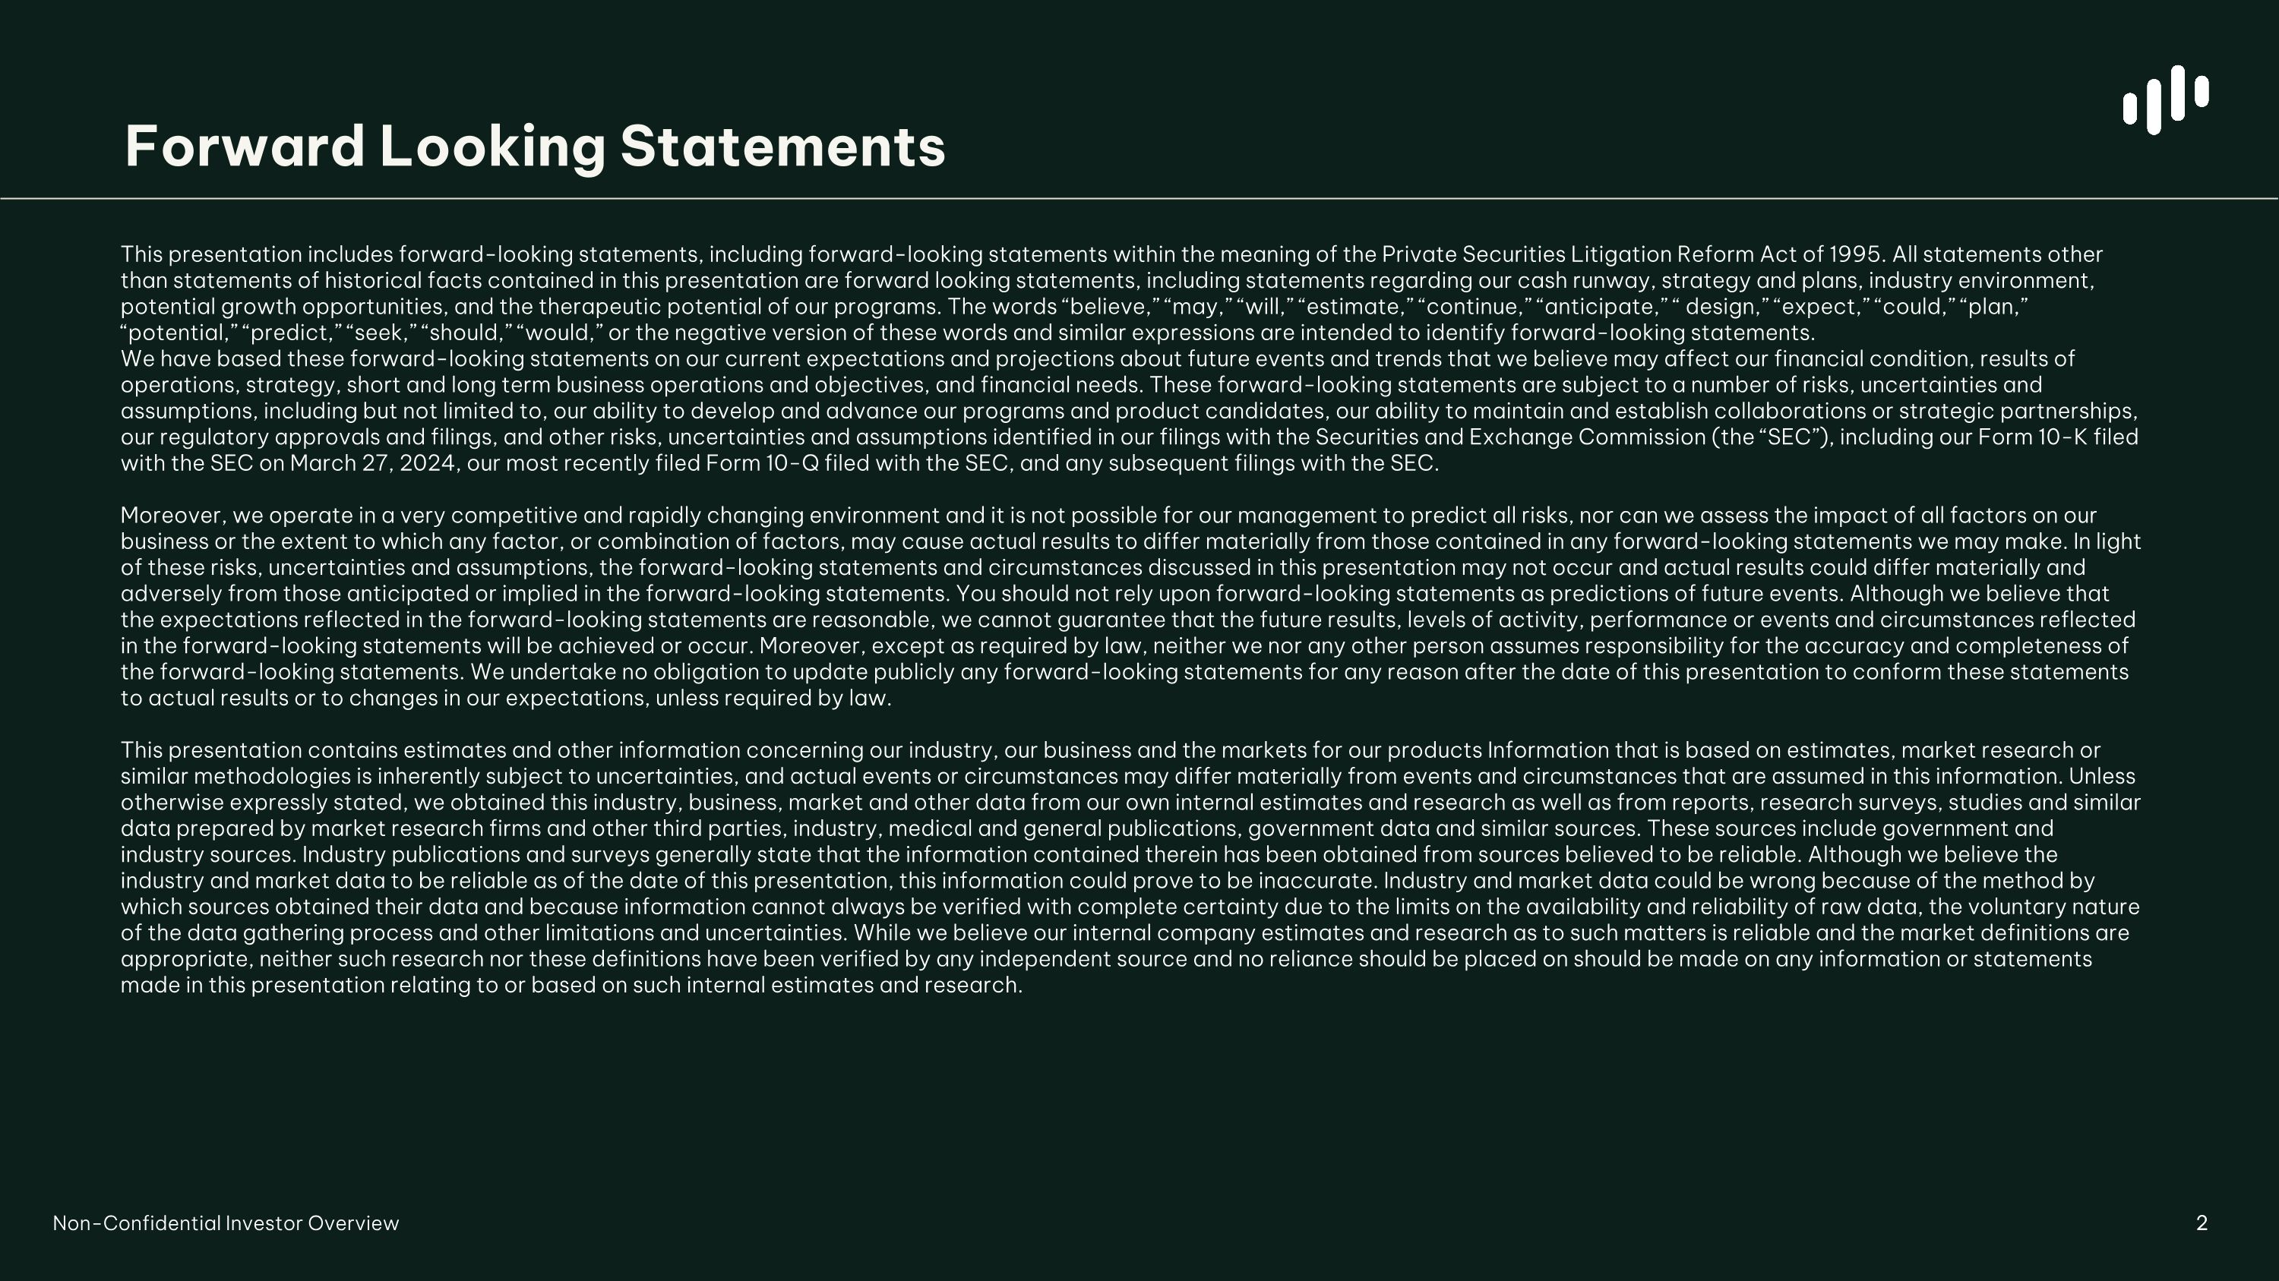
Forward Looking Statements This presentation includes forward-looking statements, including forward-looking statements within the meaning of the Private Securities Litigation Reform Act of 1995. All statements other than statements of historical facts contained in this presentation are forward looking statements, including statements regarding our cash runway, strategy and plans, industry environment, potential growth opportunities, and the therapeutic potential of our programs. The words “believe,” “may,” “will,” “estimate,” “continue,” “anticipate,” “ design,” “expect,” “could,” “plan,” “potential,” “predict,” “seek,” “should,” “would,” or the negative version of these words and similar expressions are intended to identify forward-looking statements. We have based these forward-looking statements on our current expectations and projections about future events and trends that we believe may affect our financial condition, results of operations, strategy, short and long term business operations and objectives, and financial needs. These forward-looking statements are subject to a number of risks, uncertainties and assumptions, including but not limited to, our ability to develop and advance our programs and product candidates, our ability to maintain and establish collaborations or strategic partnerships, our regulatory approvals and filings, and other risks, uncertainties and assumptions identified in our filings with the Securities and Exchange Commission (the “SEC”), including our Form 10-K filed with the SEC on March 27, 2024, our most recently filed Form 10-Q filed with the SEC, and any subsequent filings with the SEC. Moreover, we operate in a very competitive and rapidly changing environment and it is not possible for our management to predict all risks, nor can we assess the impact of all factors on our business or the extent to which any factor, or combination of factors, may cause actual results to differ materially from those contained in any forward-looking statements we may make. In light of these risks, uncertainties and assumptions, the forward-looking statements and circumstances discussed in this presentation may not occur and actual results could differ materially and adversely from those anticipated or implied in the forward-looking statements. You should not rely upon forward-looking statements as predictions of future events. Although we believe that the expectations reflected in the forward-looking statements are reasonable, we cannot guarantee that the future results, levels of activity, performance or events and circumstances reflected in the forward-looking statements will be achieved or occur. Moreover, except as required by law, neither we nor any other person assumes responsibility for the accuracy and completeness of the forward-looking statements. We undertake no obligation to update publicly any forward-looking statements for any reason after the date of this presentation to conform these statements to actual results or to changes in our expectations, unless required by law. This presentation contains estimates and other information concerning our industry, our business and the markets for our products Information that is based on estimates, market research or similar methodologies is inherently subject to uncertainties, and actual events or circumstances may differ materially from events and circumstances that are assumed in this information. Unless otherwise expressly stated, we obtained this industry, business, market and other data from our own internal estimates and research as well as from reports, research surveys, studies and similar data prepared by market research firms and other third parties, industry, medical and general publications, government data and similar sources. These sources include government and industry sources. Industry publications and surveys generally state that the information contained therein has been obtained from sources believed to be reliable. Although we believe the industry and market data to be reliable as of the date of this presentation, this information could prove to be inaccurate. Industry and market data could be wrong because of the method by which sources obtained their data and because information cannot always be verified with complete certainty due to the limits on the availability and reliability of raw data, the voluntary nature of the data gathering process and other limitations and uncertainties. While we believe our internal company estimates and research as to such matters is reliable and the market definitions are appropriate, neither such research nor these definitions have been verified by any independent source and no reliance should be placed on should be made on any information or statements made in this presentation relating to or based on such internal estimates and research. 2 Non-Confidential Investor Overview

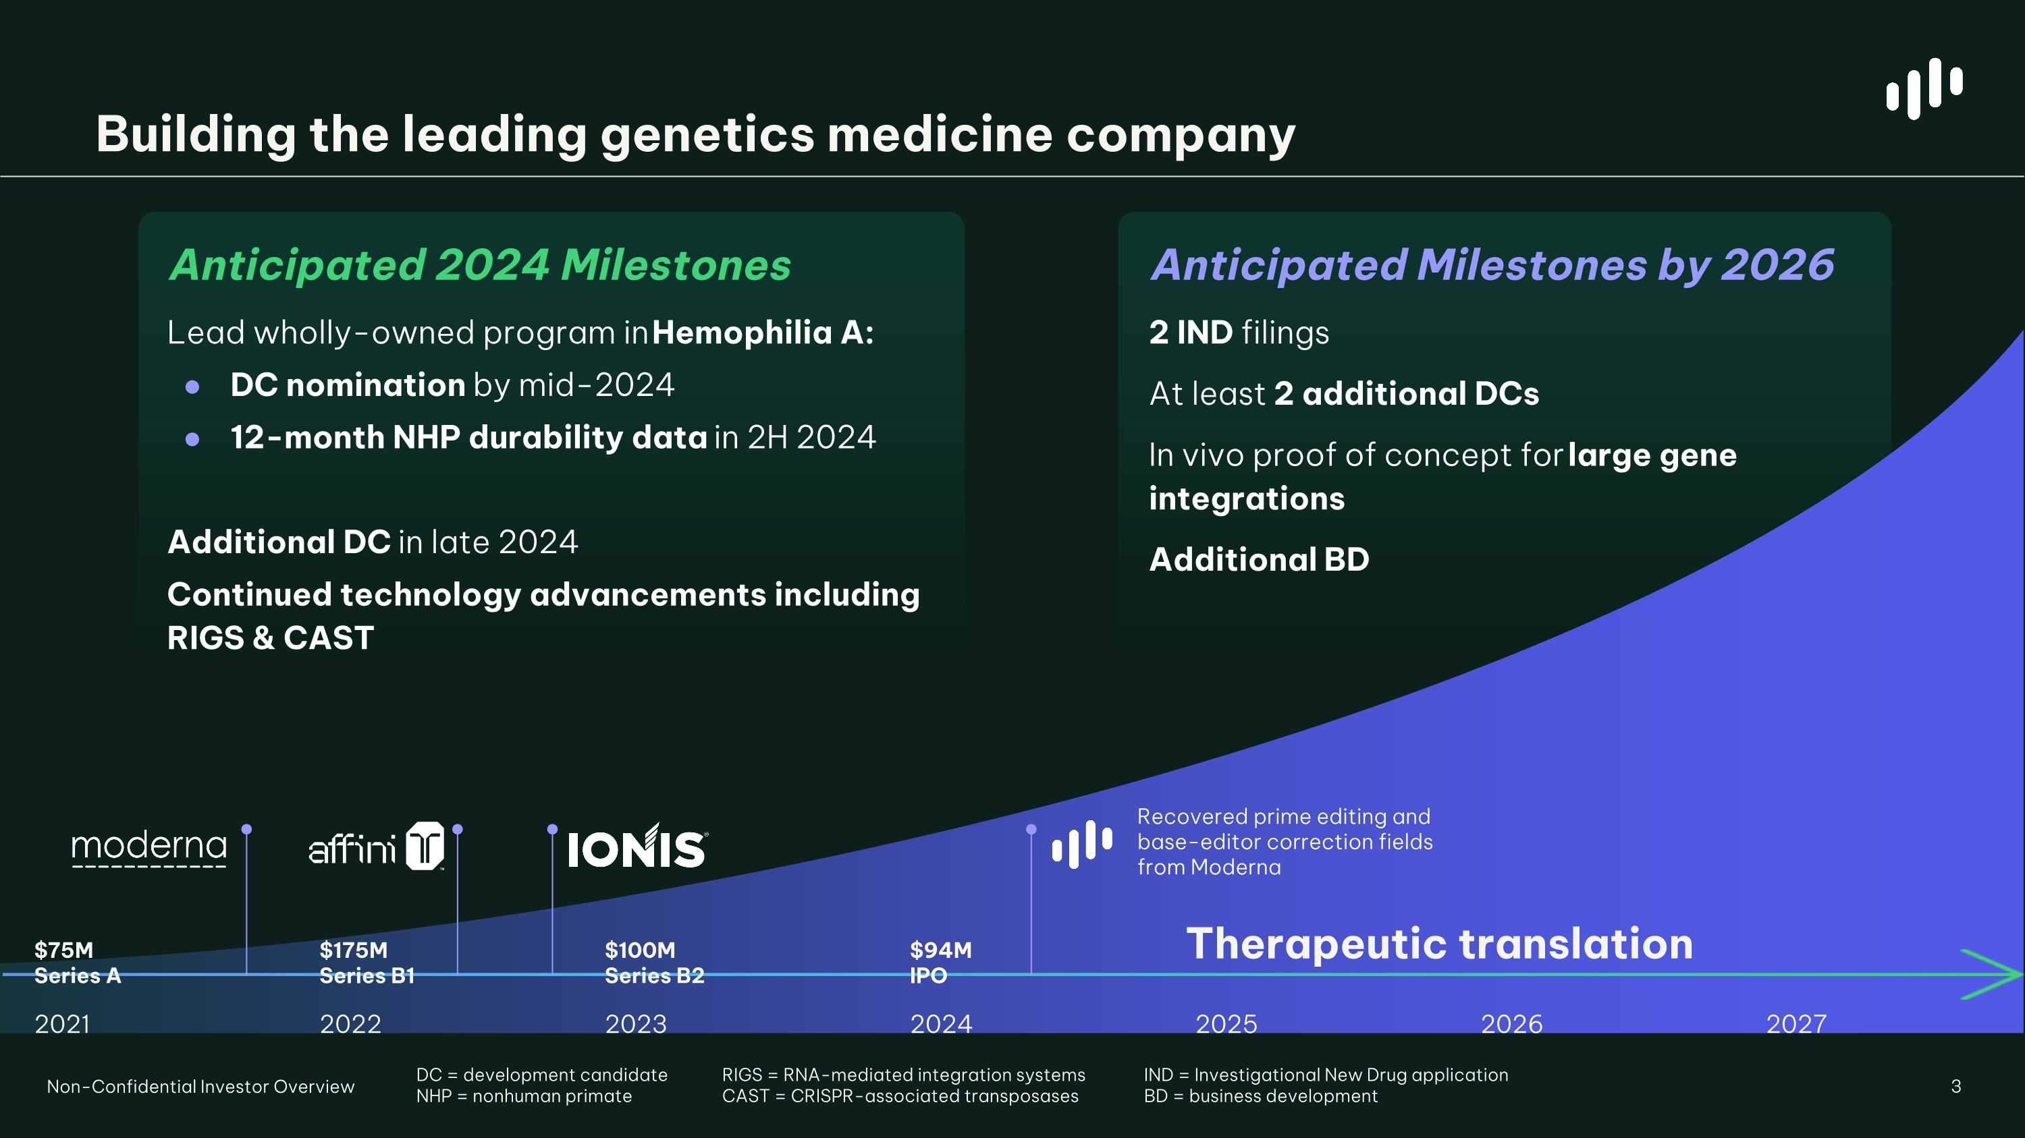
Building the leading genetics medicine company 3 Non-Confidential Investor Overview Therapeutic translation $175M ?Series B1 2022 $100M ?Series B2 2023 $75M ?Series A 2021 $94M ?IPO 2024 2025 2026 Anticipated Milestones by 2026 2 IND filings At least 2 additional DCs In vivo proof of concept for large gene integrations Additional BD Anticipated 2024 Milestones Lead wholly-owned program in Hemophilia A: DC nomination by mid-2024 12-month NHP durability data in 2H 2024 Additional DC in late 2024 Continued technology advancements including RIGS & CAST 2027 DC = development candidate NHP = nonhuman primate RIGS = RNA-mediated integration systems CAST = CRISPR-associated transposases IND = Investigational New Drug application BD = business development Recovered prime editing and base-editor correction fields from Moderna

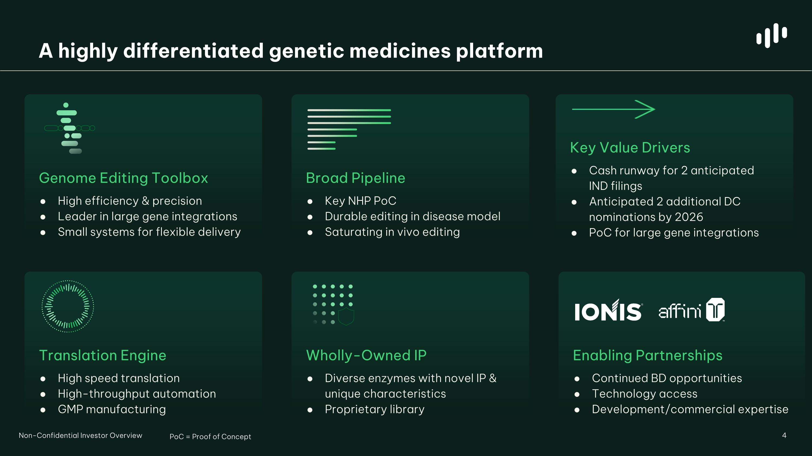
Wholly-Owned IP Diverse enzymes with novel IP & unique characteristics Proprietary library A highly differentiated genetic medicines platform 4 Broad Pipeline Key NHP PoC Durable editing in disease model Saturating in vivo editing Genome Editing Toolbox High efficiency & precision Leader in large gene integrations Small systems for flexible delivery Enabling Partnerships Continued BD opportunities Technology access Development/commercial expertise Translation Engine High speed translation High-throughput automation GMP manufacturing Key Value Drivers Cash runway for 2 anticipated ?IND filings Anticipated 2 additional DC nominations by 2026 PoC for large gene integrations Non-Confidential Investor Overview PoC = Proof of Concept

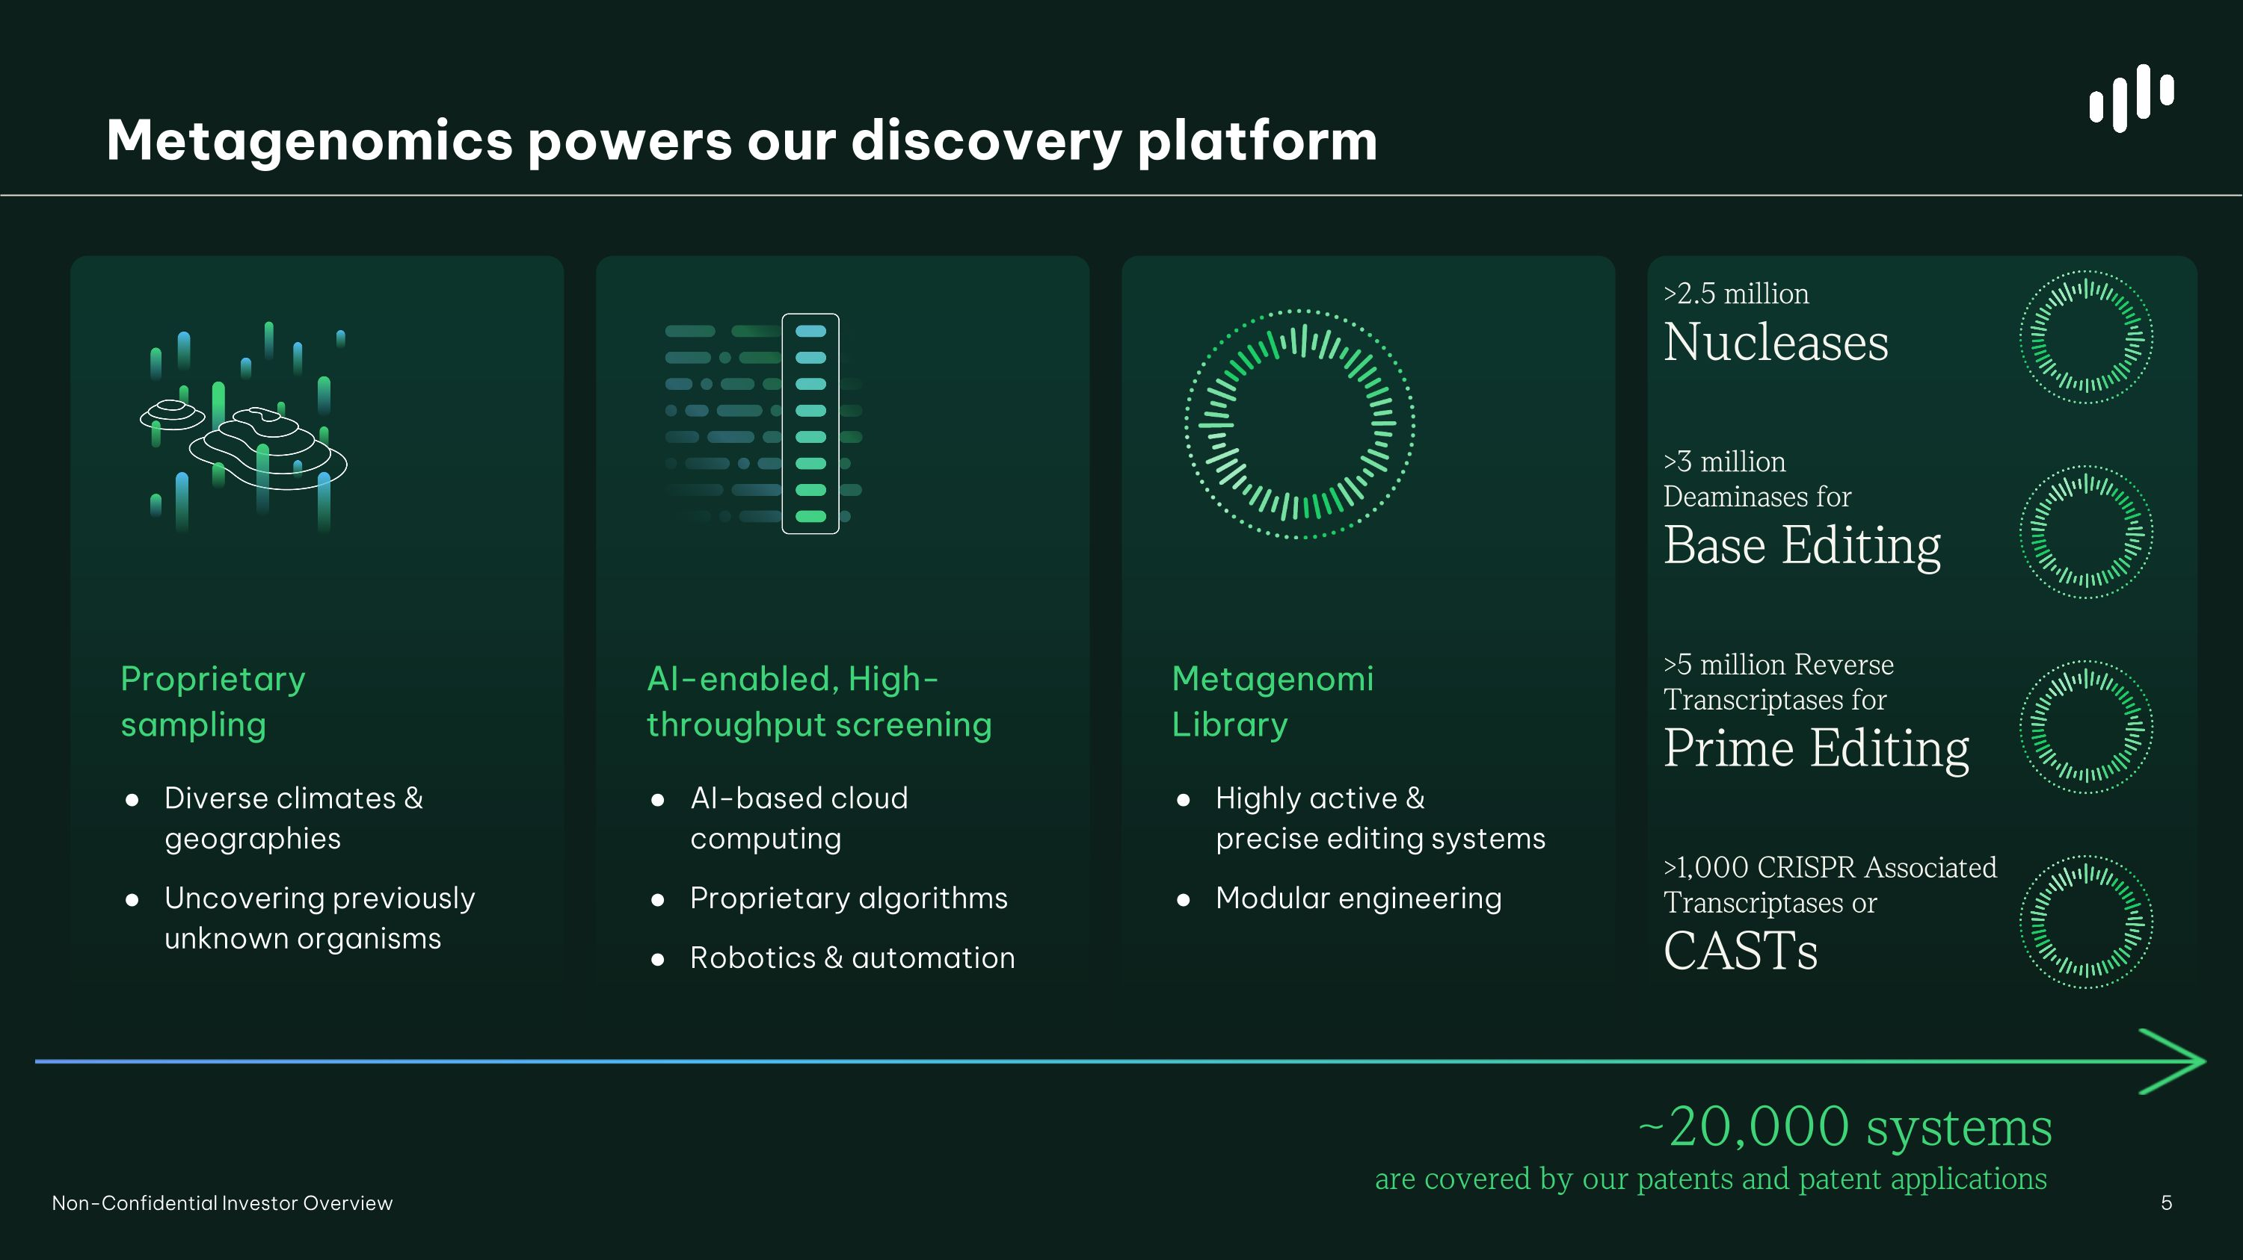
AI-enabled, High-?throughput screening AI-based cloud computing Proprietary algorithms Robotics & automation Metagenomi?Library Highly active & ?precise editing systems Modular engineering Metagenomics powers our discovery platform Proprietary ?sampling Diverse climates & geographies Uncovering previously unknown organisms >2.5 million ?Nucleases >3 million ?Deaminases for ?Base Editing >5 million Reverse ?Transcriptases for Prime Editing >1,000 CRISPR Associated Transcriptases or?CASTs ~20,000 systems ?are covered by our patents and patent applications Non-Confidential Investor Overview

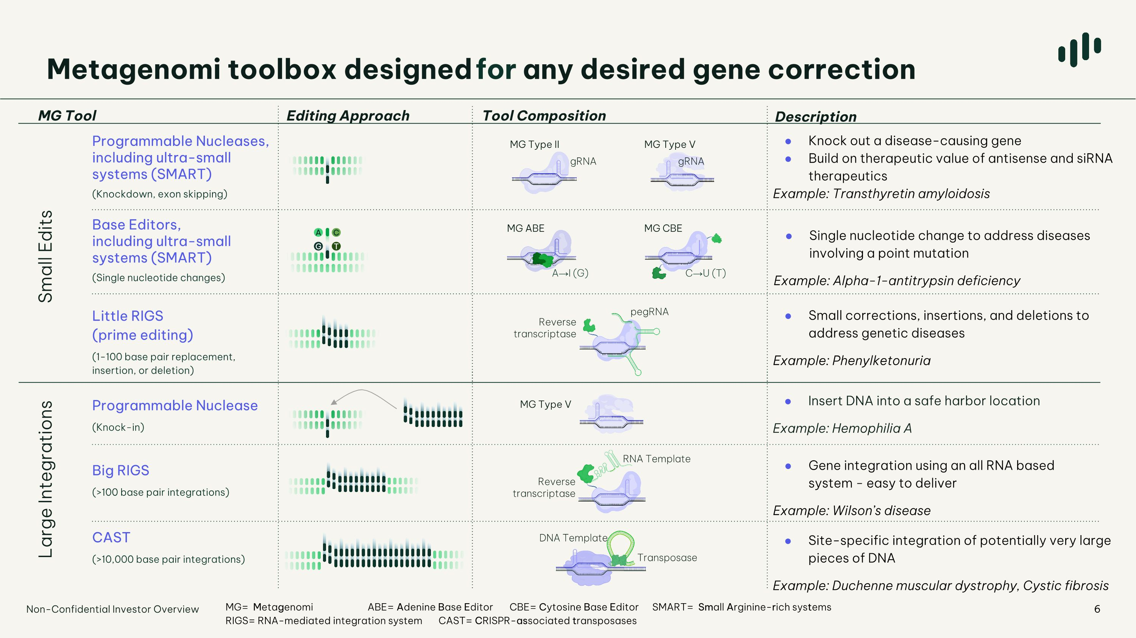
6 Programmable Nucleases, including ultra-small systems (SMART) (Knockdown, exon skipping) Base Editors,?including ultra-small systems (SMART) (Single nucleotide changes) Big RIGS (>100 base pair integrations) Little RIGS ?(prime editing) (1-100 base pair replacement, ?insertion, or deletion) G A T C Metagenomi toolbox designed for any desired gene correction Knock out a disease-causing gene Build on therapeutic value of antisense and siRNA therapeutics Example: Transthyretin amyloidosis Single nucleotide change to address diseases involving a point mutation Example: Alpha-1-antitrypsin deficiency Small corrections, insertions, and deletions to address genetic diseases Example: Phenylketonuria CAST (>10,000 base pair integrations) Gene integration using an all RNA based system - easy to deliver Example: Wilson’s disease Site-specific integration of potentially very large pieces of DNA Example: Duchenne muscular dystrophy, Cystic fibrosis MG Type II MG Type V gRNA gRNA MG ABE MG CBE C→U (T) A→I (G) Reverse transcriptase RNA Template DNA Template Transposase MG Tool Description Editing Approach Tool Composition Small Edits Large Integrations Reverse transcriptase pegRNA Programmable Nuclease (Knock-in) Insert DNA into a safe harbor location Example: Hemophilia A MG Type V Non-Confidential Investor Overview MG= Metagenomi ABE= Adenine Base Editor CBE= Cytosine Base Editor SMART= Small Arginine-rich systems RIGS= RNA-mediated integration system CAST= CRISPR-associated transposases

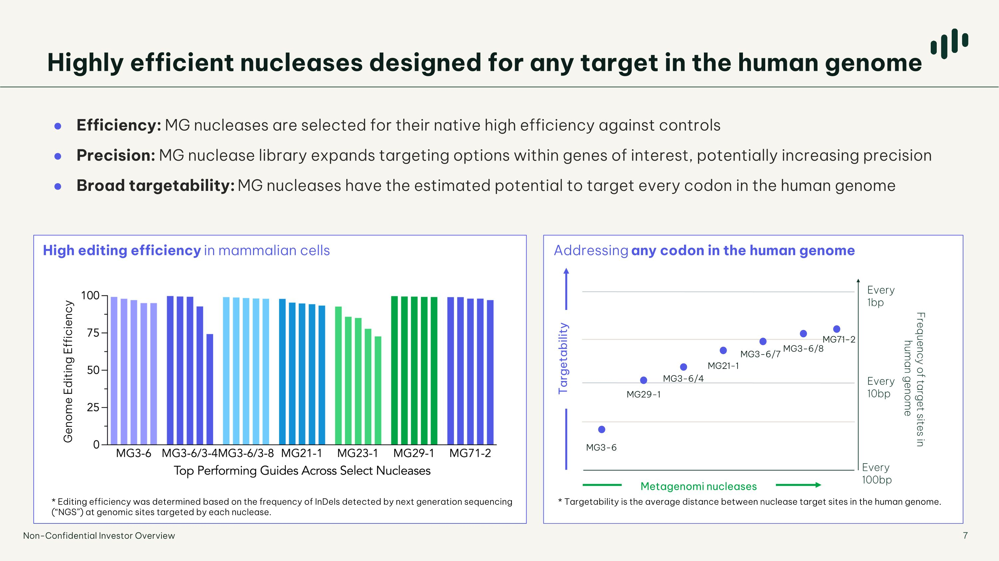
Efficiency: MG nucleases are selected for their native high efficiency against controls Precision: MG nuclease library expands targeting options within genes of interest, potentially increasing precision Broad targetability: MG nucleases have the estimated potential to target every codon in the human genome * Editing efficiency was determined based on the frequency of InDels detected by next generation sequencing (“NGS”) at genomic sites targeted by each nuclease. * Targetability is the average distance between nuclease target sites in the human genome. Highly efficient nucleases designed for any target in the human genome 7 High editing efficiency in mammalian cells Addressing any codon in the human genome Genome Editing Efficiency Frequency of target sites in human genome Every 100bp Every 10bp Every ?1bp Targetability Metagenomi nucleases MG3-6 MG29-1 MG3-6/4 MG21-1 MG3-6/7 MG3-6/8 MG71-2 Non-Confidential Investor Overview

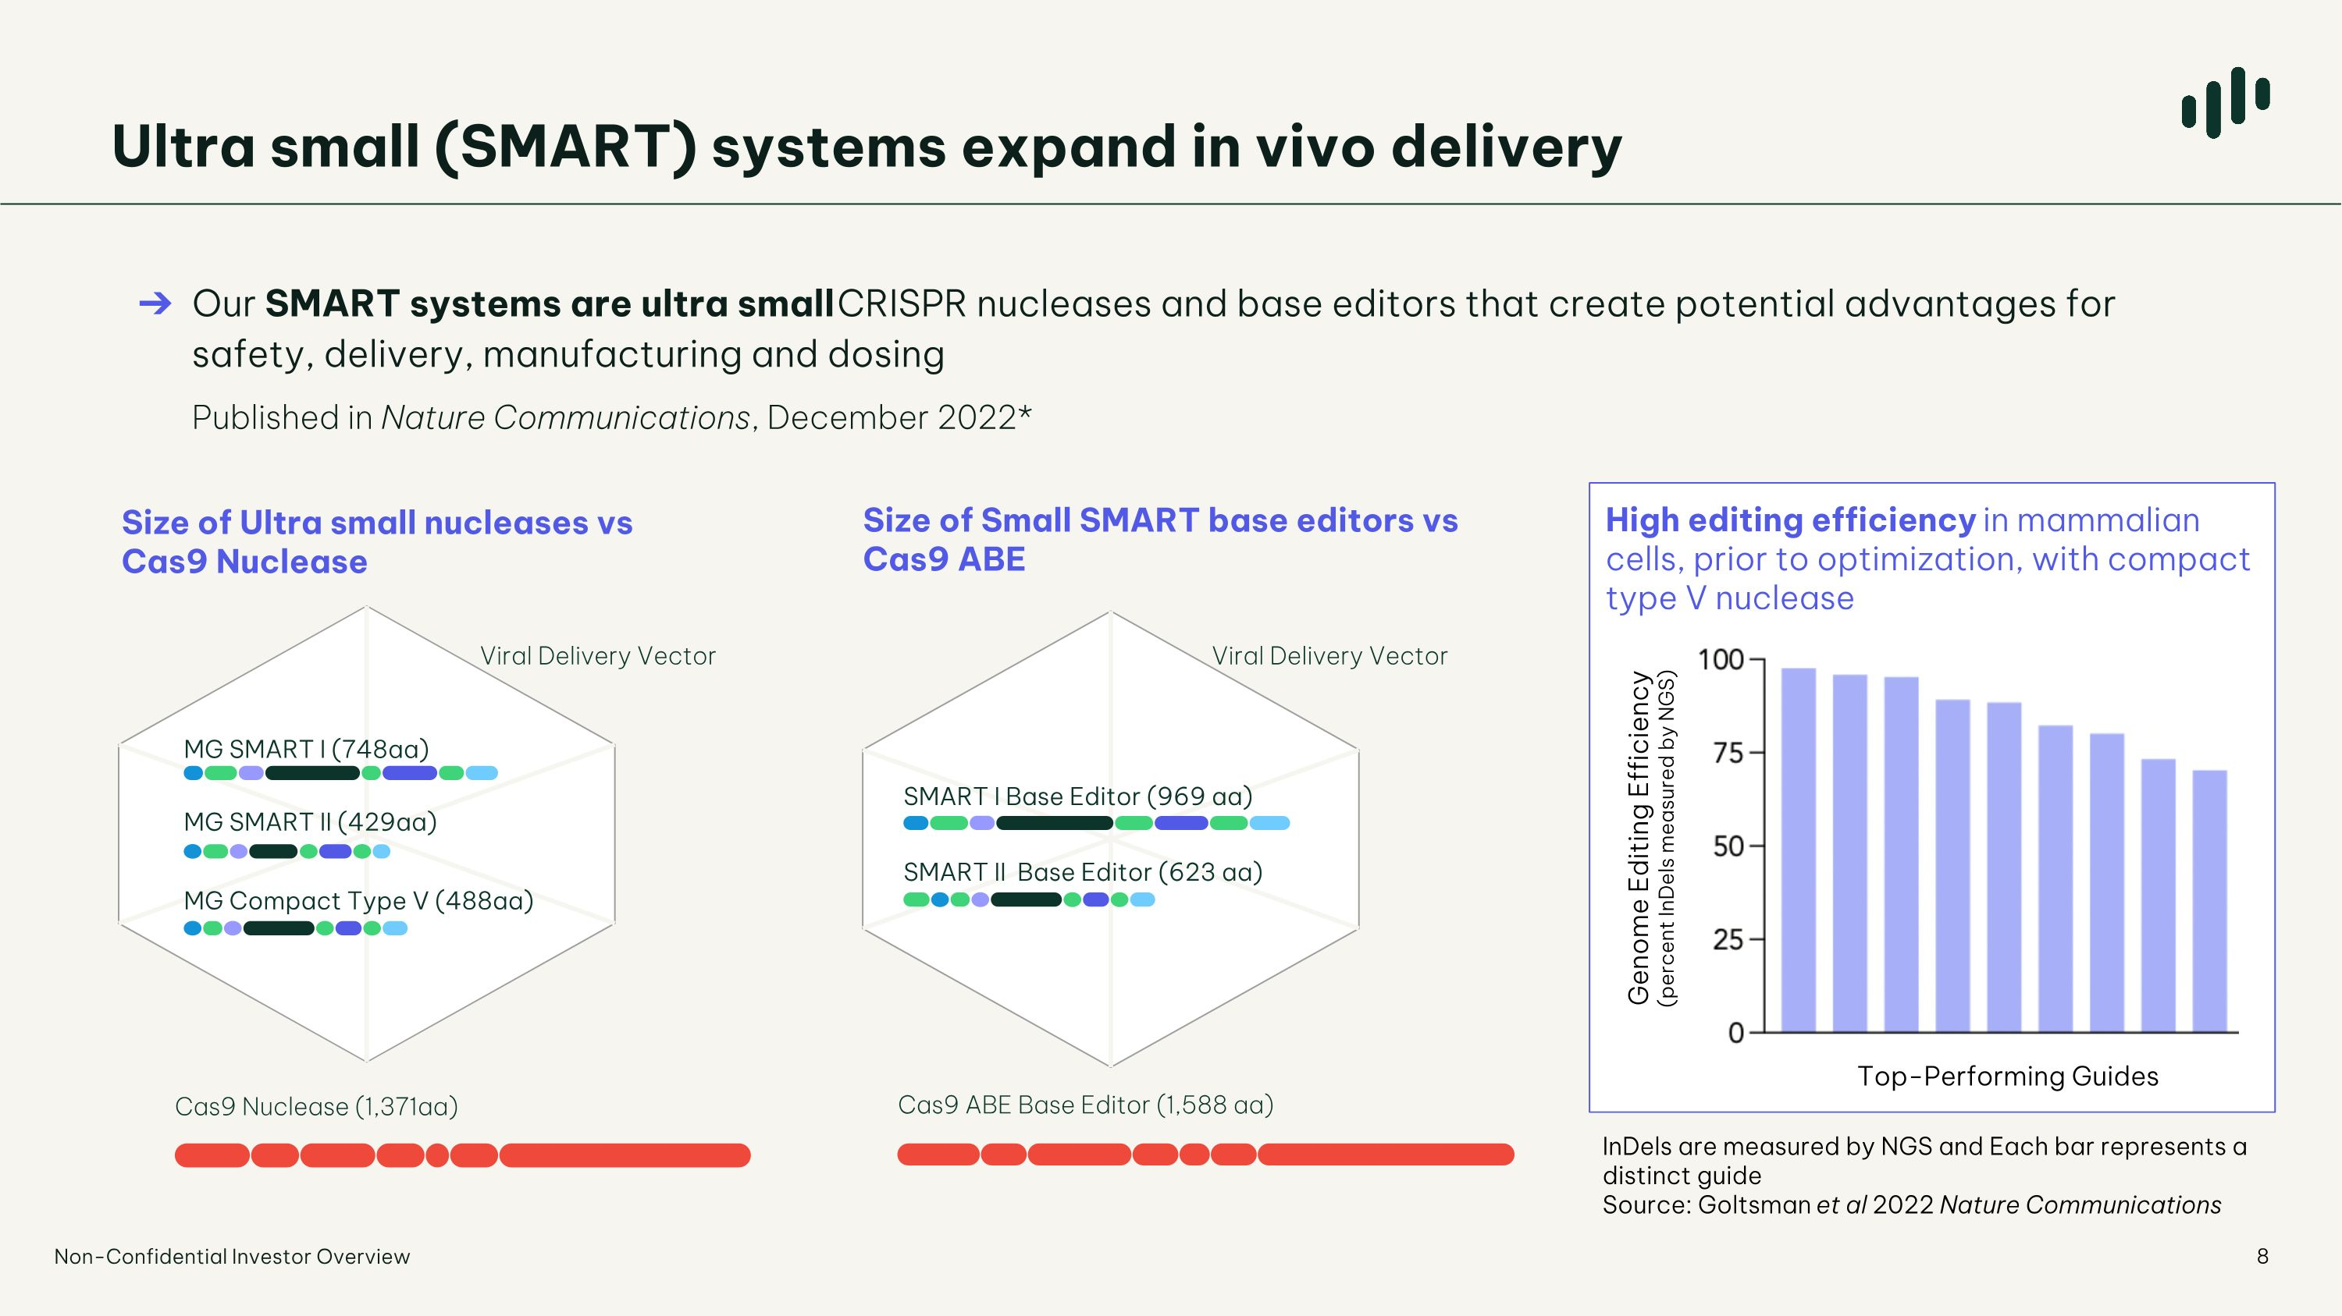
Ultra small (SMART) systems expand in vivo delivery Our SMART systems are ultra small CRISPR nucleases and base editors that create potential advantages for safety, delivery, manufacturing and dosing Published in Nature Communications, December 2022* Size of Small SMART base editors vs Cas9 ABE Cas9 ABE Base Editor (1,588 aa) SMART I Base Editor (969 aa) SMART II Base Editor (623 aa) Size of Ultra small nucleases vs Cas9 Nuclease MG SMART I (748aa) MG SMART II (429aa) MG Compact Type V (488aa) Cas9 Nuclease (1,371aa) High editing efficiency in mammalian cells, prior to optimization, with compact type V nuclease Genome Editing Efficiency?(percent InDels measured by NGS) Top-Performing Guides InDels are measured by NGS and Each bar represents a distinct guide Source: Goltsman et al 2022 Nature Communications Non-Confidential Investor Overview Viral Delivery Vector Viral Delivery Vector

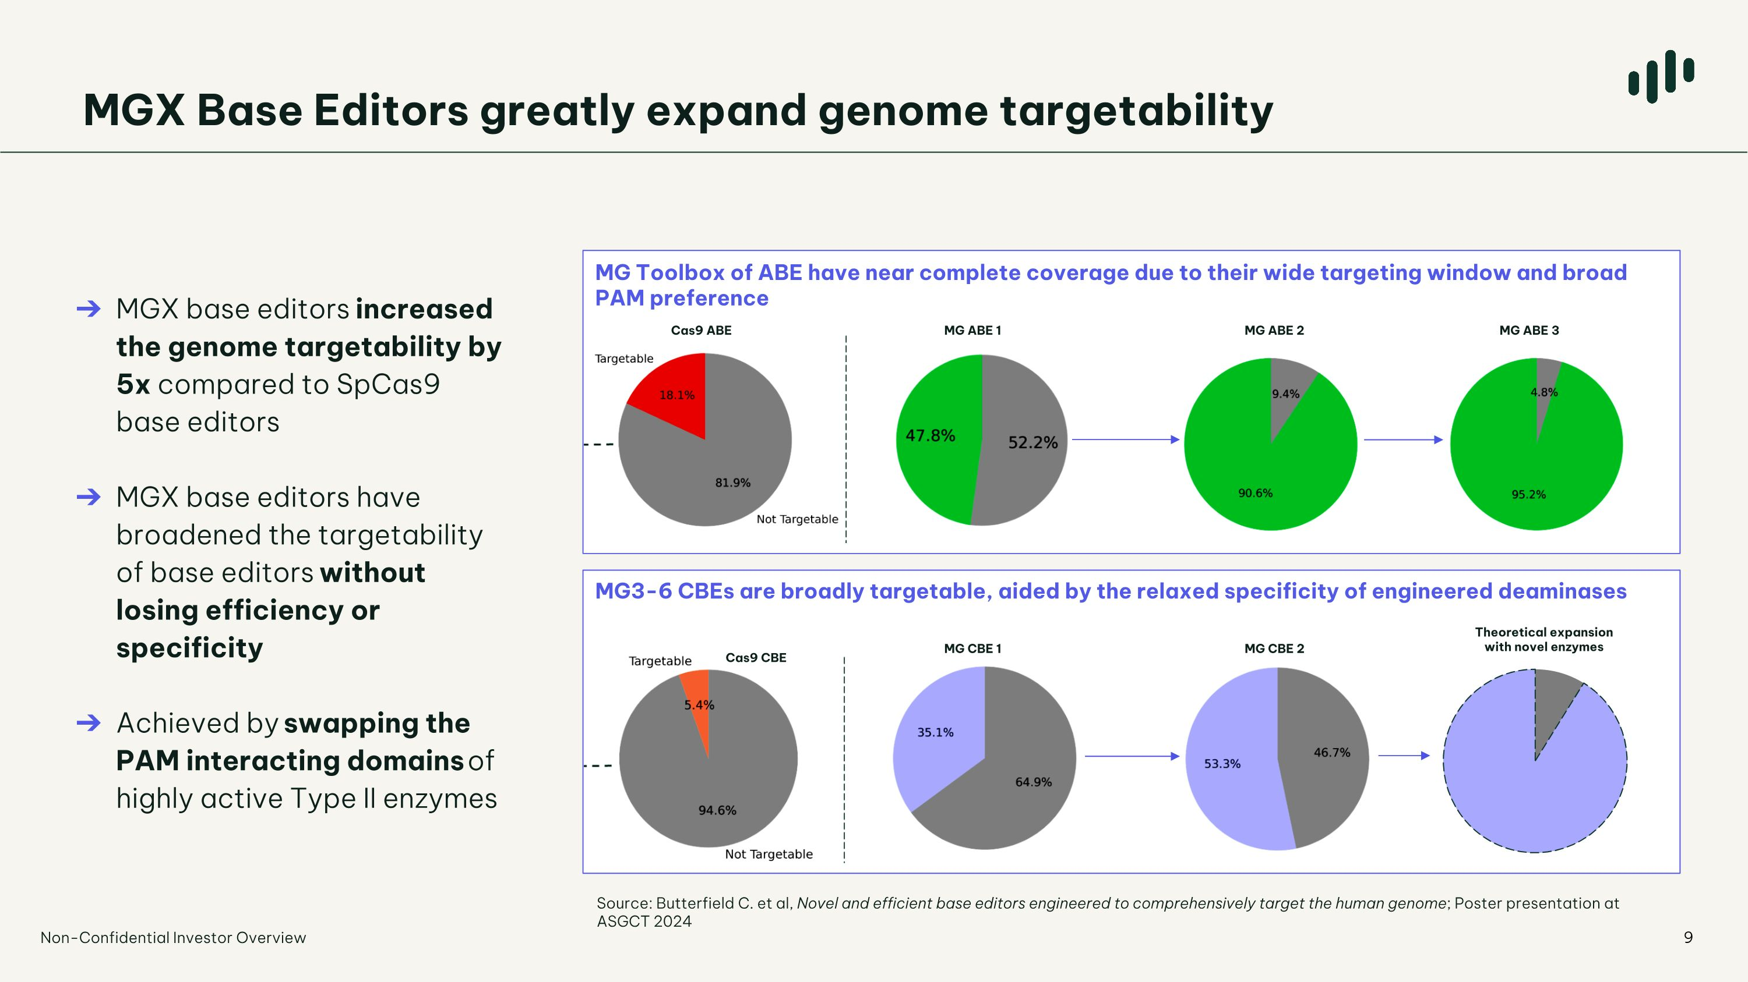
MGX Base Editors greatly expand genome targetability MGX base editors increased the genome targetability by 5x compared to SpCas9 base editors MGX base editors have broadened the targetability of base editors without losing efficiency or specificity Achieved by swapping the PAM interacting domains of highly active Type II enzymes Non-Confidential Investor Overview MG Toolbox of ABE have near complete coverage due to their wide targeting window and broad PAM preference MG3-6 CBEs are broadly targetable, aided by the relaxed specificity of engineered deaminases Cas9 ABE MG ABE 1 MG ABE 2 MG ABE 3 Cas9 CBE MG CBE 1 MG CBE 2 Theoretical expansion with novel enzymes Source: Butterfield C. et al, Novel and efficient base editors engineered to comprehensively target the human genome; Poster presentation at ASGCT 2024

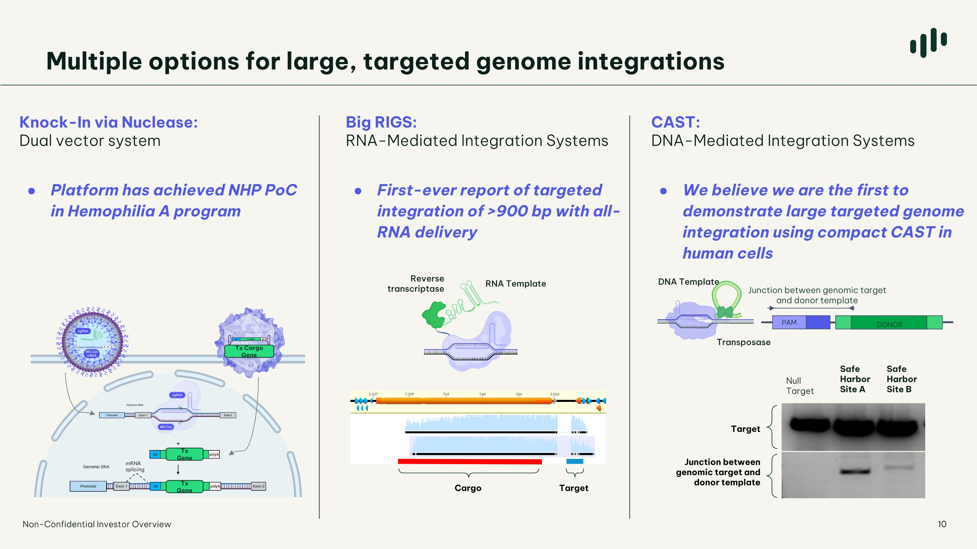
Multiple options for large, targeted genome integrations CAST:?DNA-Mediated Integration Systems Big RIGS: RNA-Mediated Integration Systems DNA Template Transposase Reverse transcriptase RNA Template Cargo Target DONOR PAM Junction between genomic target and donor template Junction between genomic target and donor template Target Null ?Target Safe ?Harbor ?Site A Safe ?Harbor ?Site B Non-Confidential Investor Overview Knock-In via Nuclease: Dual vector system mRNA splicing Tx Cargo Gene Tx Gene Tx Gene First-ever report of targeted integration of >900 bp with all-RNA delivery Platform has achieved NHP PoC?in Hemophilia A program We believe we are the first to demonstrate large targeted genome integration using compact CAST in human cells

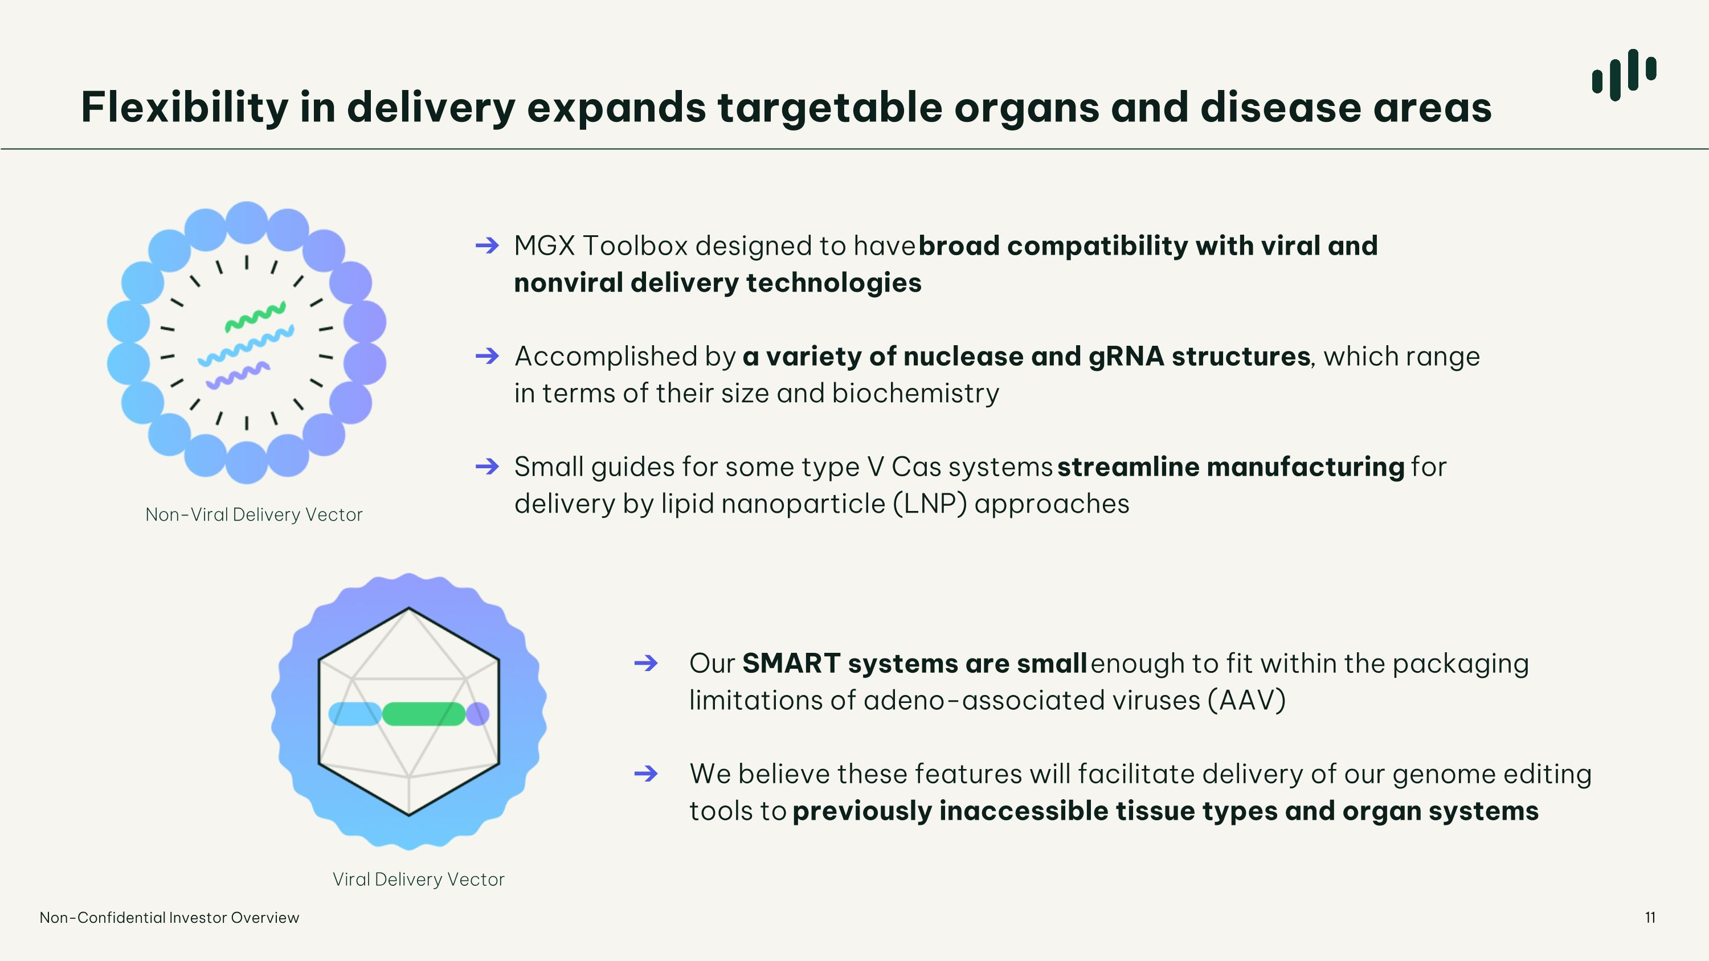
Flexibility in delivery expands targetable organs and disease areas MGX Toolbox designed to have broad compatibility with viral and nonviral delivery technologies Accomplished by a variety of nuclease and gRNA structures, which range in terms of their size and biochemistry Small guides for some type V Cas systems streamline manufacturing for delivery by lipid nanoparticle (LNP) approaches Our SMART systems are small enough to fit within the packaging limitations of adeno-associated viruses (AAV) We believe these features will facilitate delivery of our genome editing tools to previously inaccessible tissue types and organ systems Viral Delivery Vector Non-Viral Delivery Vector Non-Confidential Investor Overview


The ability to edit anywhere in the human genome, ?with high precision, tailored for each therapeutic indication Non-Confidential Investor Overview

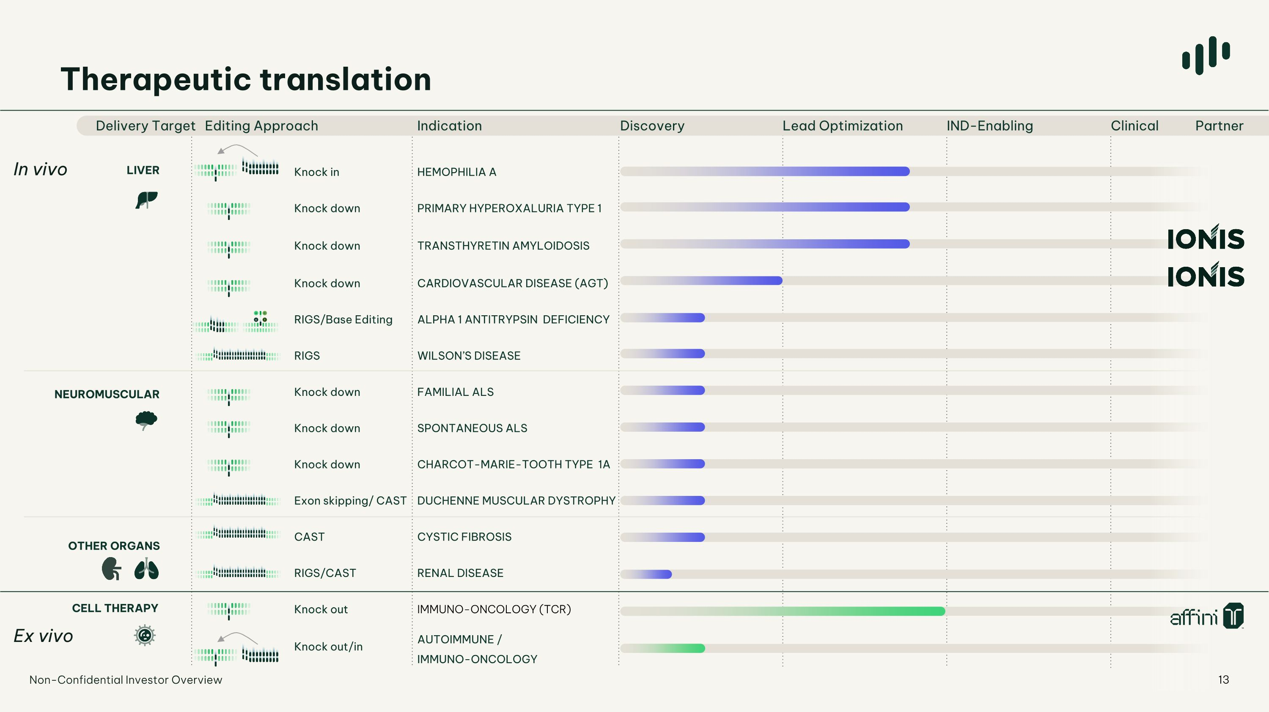
Delivery Target Editing Approach Indication Discovery Lead Optimization IND-Enabling Clinical Partner Knock in HEMOPHILIA A Knock down PRIMARY HYPEROXALURIA TYPE 1 Knock down TRANSTHYRETIN AMYLOIDOSIS Knock down CARDIOVASCULAR DISEASE (AGT) RIGS/Base Editing ALPHA 1 ANTITRYPSIN DEFICIENCY RIGS WILSON’S DISEASE Knock down FAMILIAL ALS Knock down SPONTANEOUS ALS Knock down CHARCOT-MARIE-TOOTH TYPE 1A Exon skipping/ CAST DUCHENNE MUSCULAR DYSTROPHY CAST CYSTIC FIBROSIS RIGS/CAST RENAL DISEASE Knock out IMMUNO-ONCOLOGY (TCR) Knock out/in AUTOIMMUNE / ?IMMUNO-ONCOLOGY In vivo Ex vivo LIVER NEUROMUSCULAR OTHER ORGANS CELL THERAPY Therapeutic translation 13 G A T C Non-Confidential Investor Overview 13

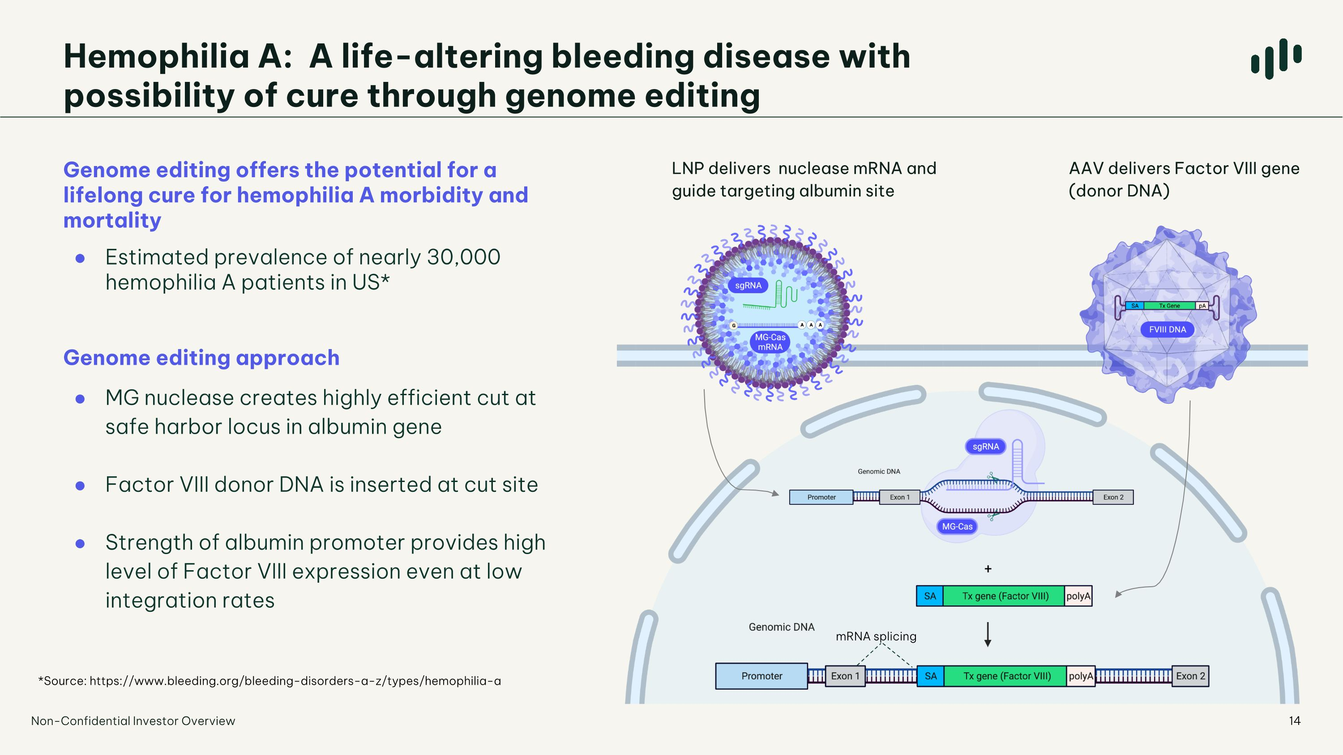
AAV delivers Factor VIII gene (donor DNA) Genome editing offers the potential for a lifelong cure for hemophilia A morbidity and mortality Estimated prevalence of nearly 30,000 hemophilia A patients in US* Genome editing approach MG nuclease creates highly efficient cut at safe harbor locus in albumin gene Factor VIII donor DNA is inserted at cut site Strength of albumin promoter provides high level of Factor VIII expression even at low integration rates LNP delivers nuclease mRNA and guide targeting albumin site mRNA splicing Hemophilia A: A life-altering bleeding disease with ?possibility of cure through genome editing Non-Confidential Investor Overview *Source: https://www.bleeding.org/bleeding-disorders-a-z/types/hemophilia-a

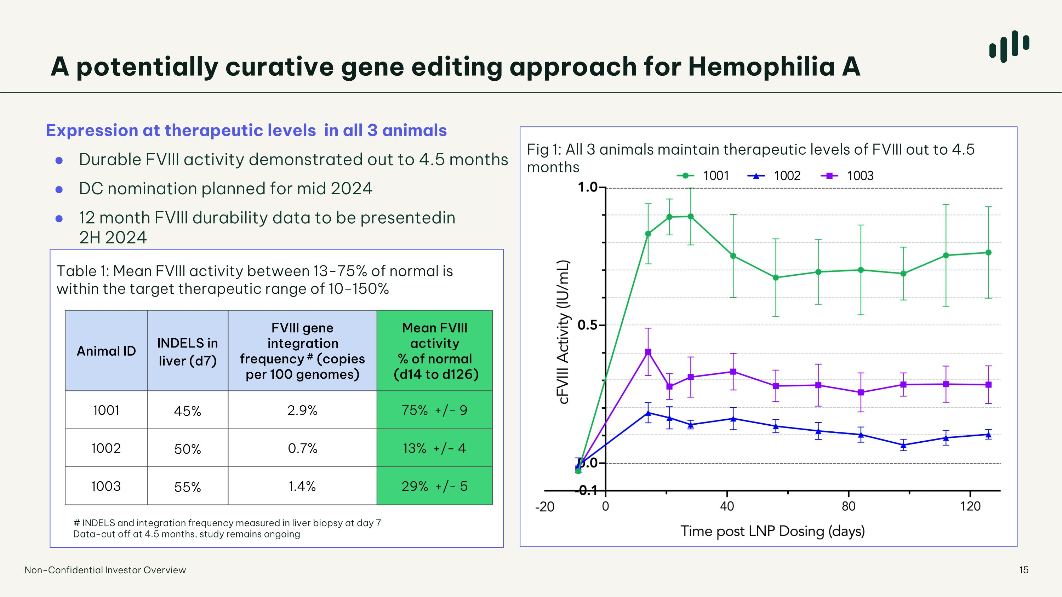
Expression at therapeutic levels in all 3 animals Durable FVIII activity demonstrated out to 4.5 months DC nomination planned for mid 2024 12 month FVIII durability data to be presented in ?2H 2024 Animal ID INDELS in liver (d7) FVIII gene integration frequency # (copies per 100 genomes) Mean FVIII activity % of normal (d14 to d126) 1001 45% 2.9% 75% +/- 9 1002 50% 0.7% 13% +/- 4 1003 55% 1.4% 29% +/- 5 # INDELS and integration frequency measured in liver biopsy at day 7 Data-cut off at 4.5 months, study remains ongoing A potentially curative gene editing approach for Hemophilia A Fig 1: All 3 animals maintain therapeutic levels of FVIII out to 4.5 months Table 1: Mean FVIII activity between 13-75% of normal is within the target therapeutic range of 10-150% Non-Confidential Investor Overview

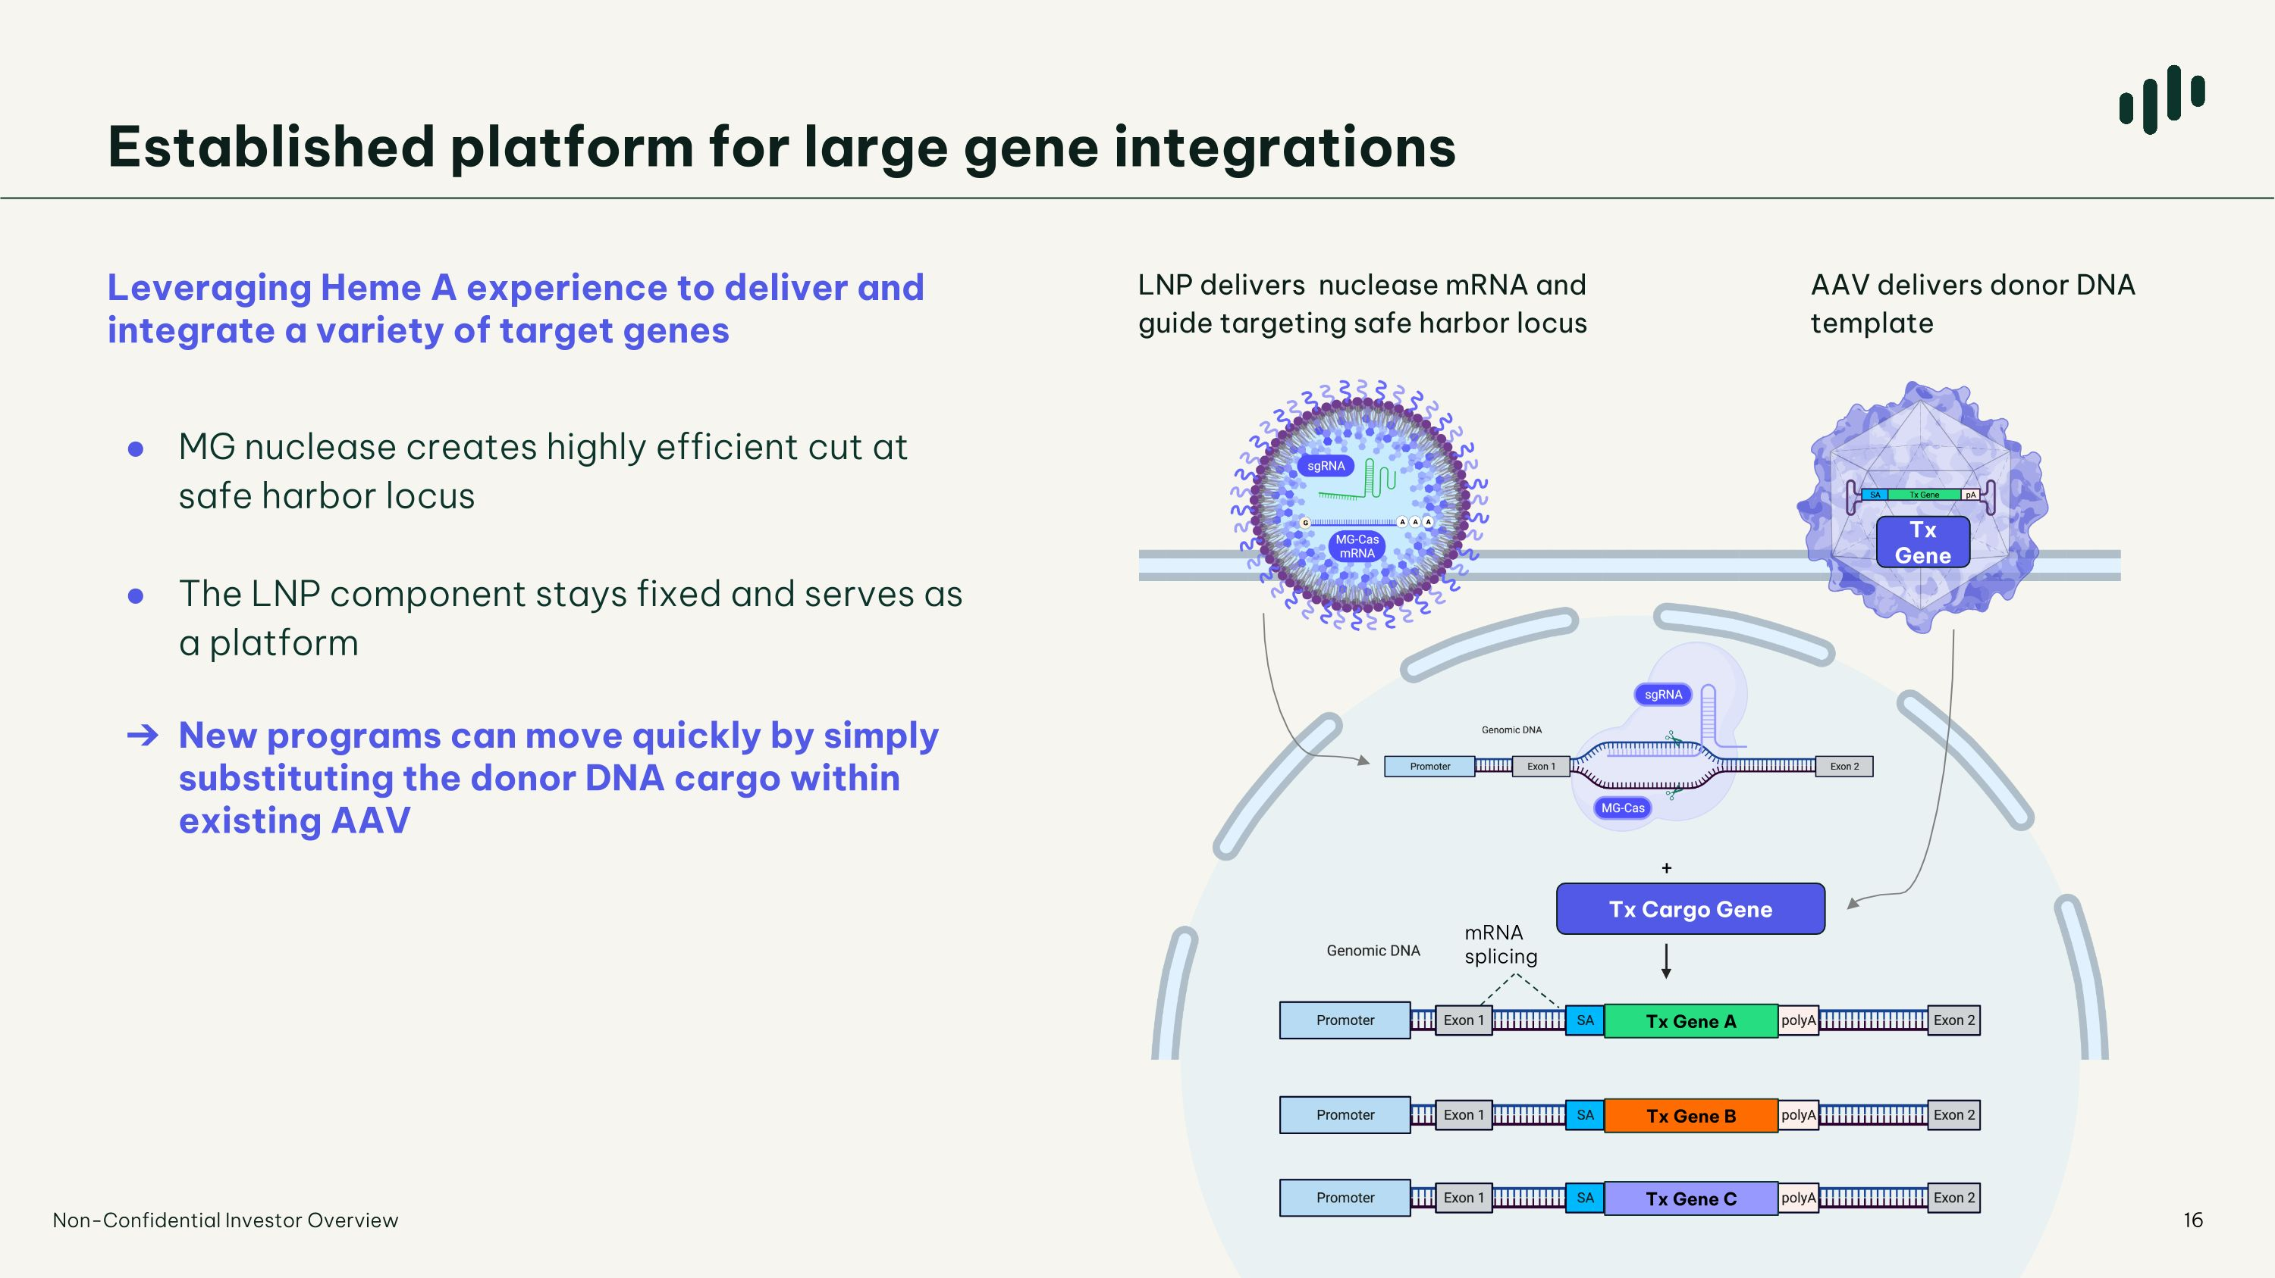
AAV delivers donor DNA template Leveraging Heme A experience to deliver and integrate a variety of target genes MG nuclease creates highly efficient cut at safe harbor locus The LNP component stays fixed and serves as a platform New programs can move quickly by simply substituting the donor DNA cargo within existing AAV LNP delivers nuclease mRNA and guide targeting safe harbor locus mRNA splicing Established platform for large gene integrations Non-Confidential Investor Overview Tx Gene Tx Gene A Tx Gene B Tx Gene C Tx Gene A Tx Cargo Gene

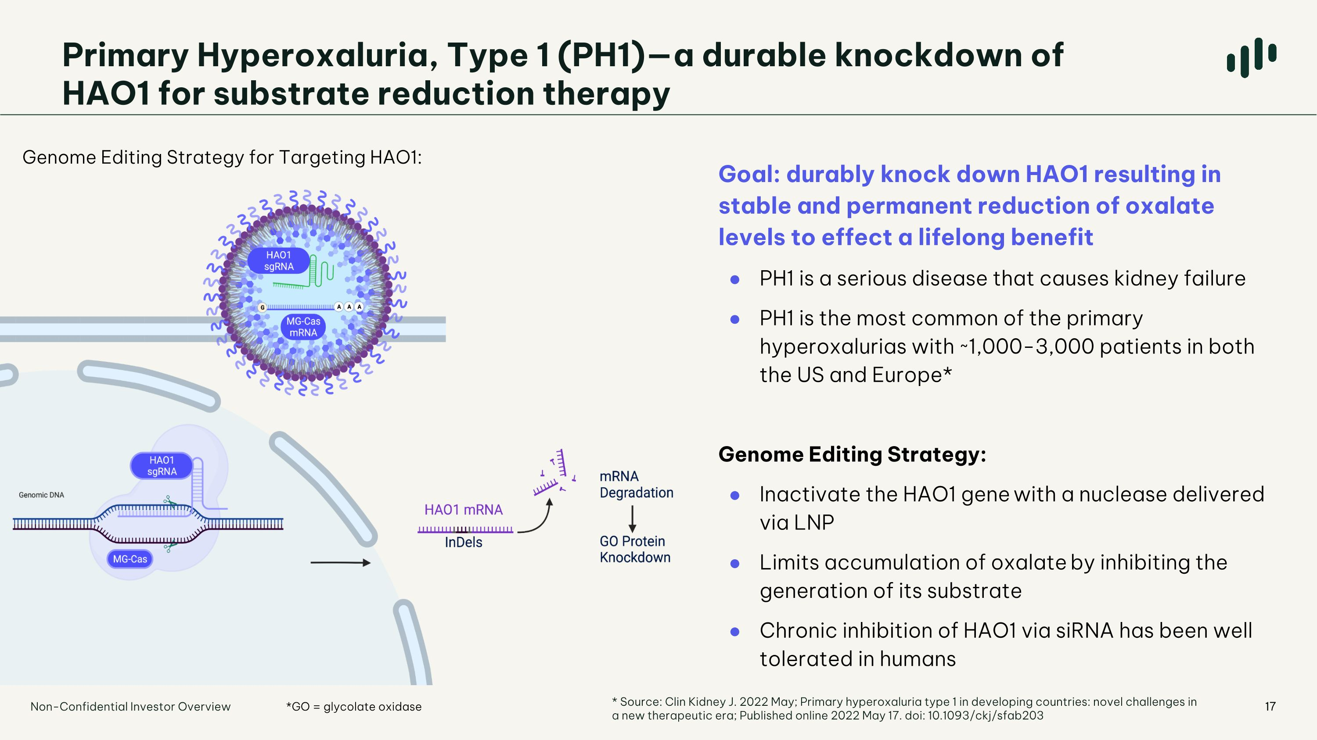
17 *GO = glycolate oxidase Primary Hyperoxaluria, Type 1 (PH1)—a durable knockdown of HAO1 for substrate reduction therapy Genome Editing Strategy for Targeting HAO1: Non-Confidential Investor Overview Goal: durably knock down HAO1 resulting in stable and permanent reduction of oxalate levels to effect a lifelong benefit PH1 is a serious disease that causes kidney failure PH1 is the most common of the primary hyperoxalurias with ~1,000-3,000 patients in both the US and Europe* Genome Editing Strategy: Inactivate the HAO1 gene with a nuclease delivered via LNP Limits accumulation of oxalate by inhibiting the generation of its substrate Chronic inhibition of HAO1 via siRNA has been well tolerated in humans * Source: Clin Kidney J. 2022 May; Primary hyperoxaluria type 1 in developing countries: novel challenges in a new therapeutic era; Published online 2022 May 17. doi: 10.1093/ckj/sfab203

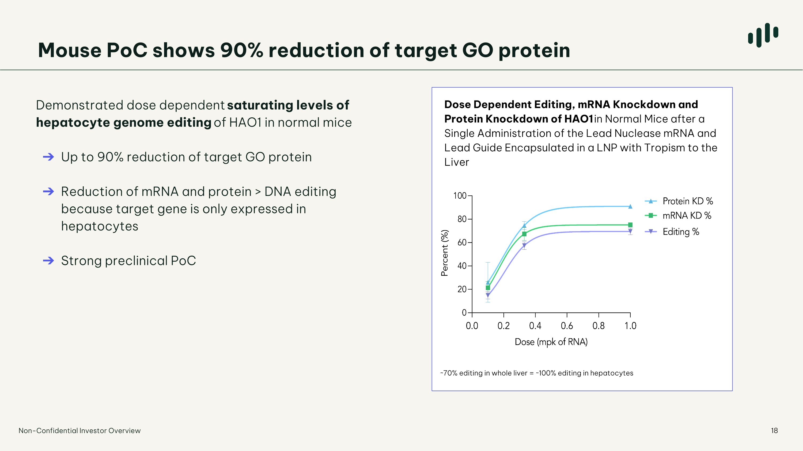
Dose Dependent Editing, mRNA Knockdown and Protein Knockdown of HAO1 in Normal Mice after a Single Administration of the Lead Nuclease mRNA and Lead Guide Encapsulated in a LNP with Tropism to the Liver ~70% editing in whole liver = ~100% editing in hepatocytes Mouse PoC shows 90% reduction of target GO protein Demonstrated dose dependent saturating levels of hepatocyte genome editing of HAO1 in normal mice Up to 90% reduction of target GO protein Reduction of mRNA and protein > DNA editing because target gene is only expressed in hepatocytes Strong preclinical PoC Non-Confidential Investor Overview

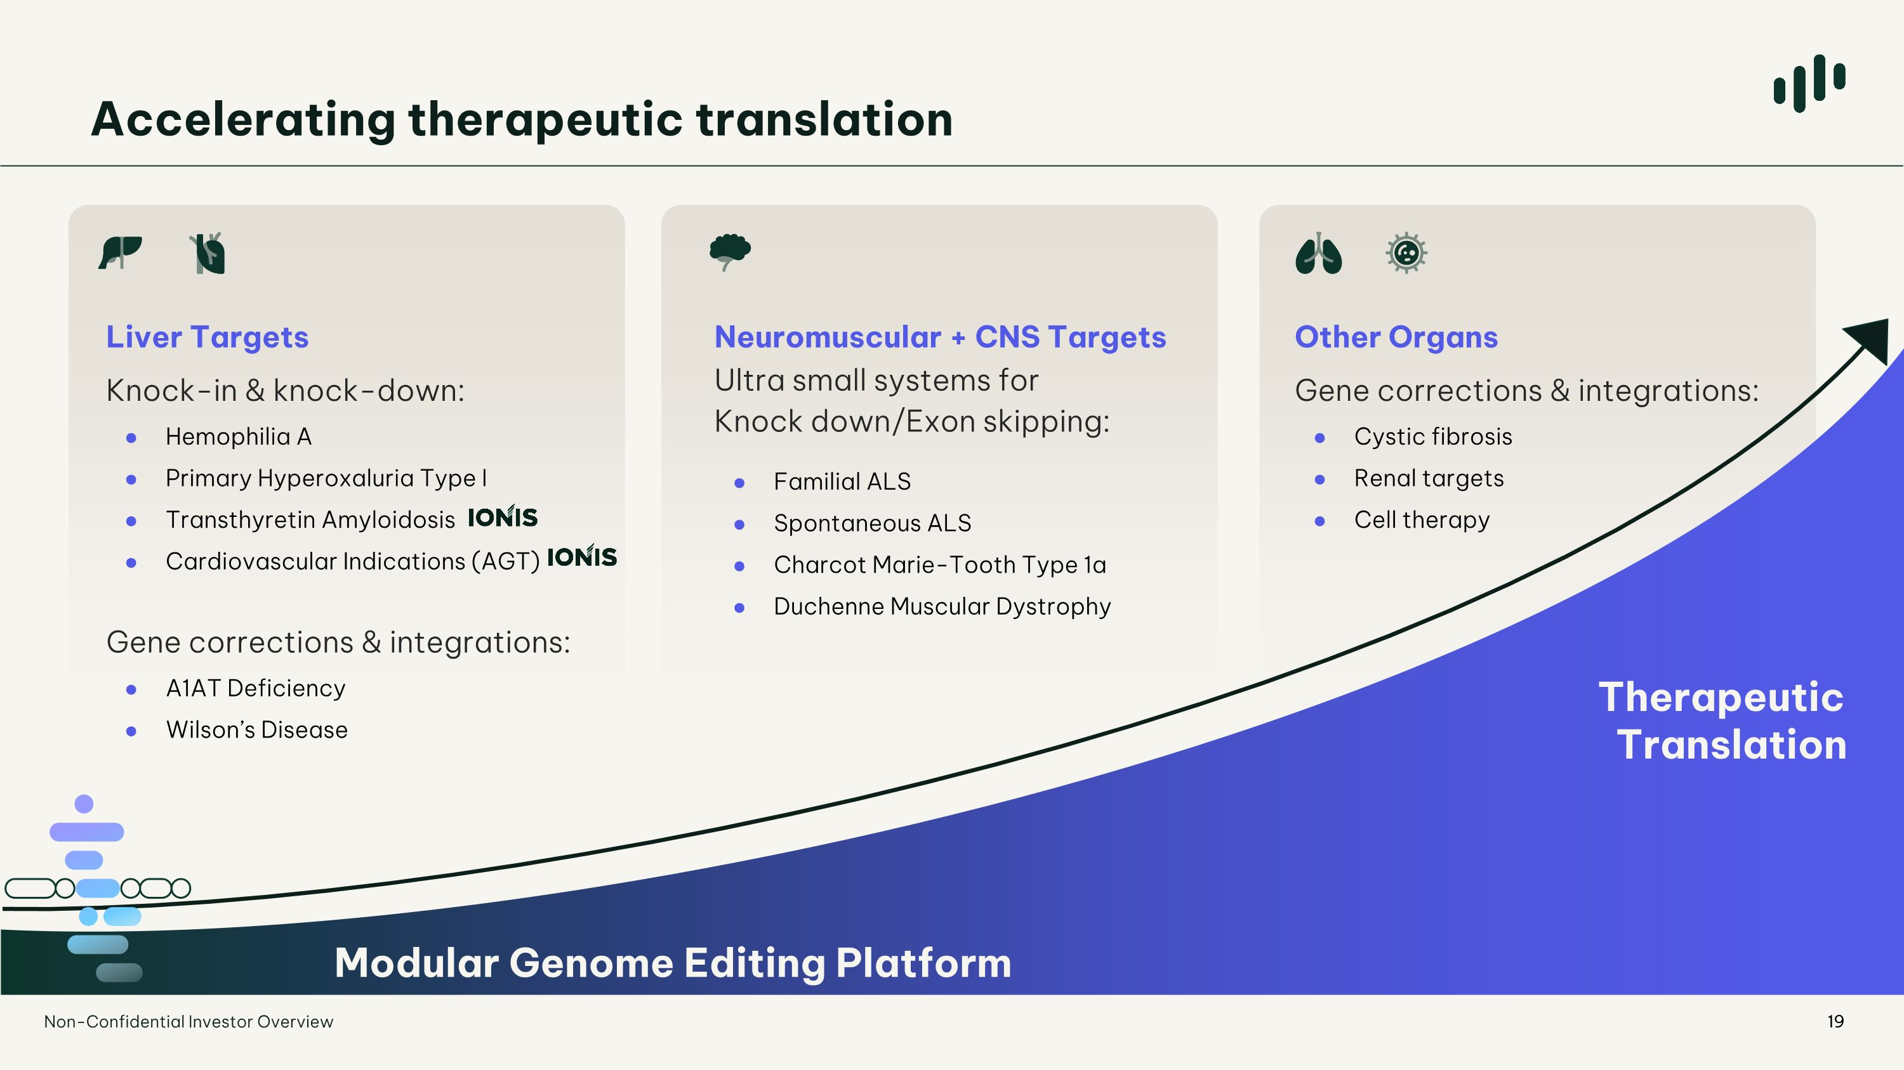
Accelerating therapeutic translation Liver Targets Knock-in & knock-down: Hemophilia A Primary Hyperoxaluria Type I Transthyretin Amyloidosis Cardiovascular Indications (AGT) Gene corrections & integrations: A1AT Deficiency Wilson’s Disease Neuromuscular + CNS Targets Ultra small systems for Knock down/Exon skipping: Familial ALS Spontaneous ALS Charcot Marie-Tooth Type 1a Duchenne Muscular Dystrophy Other Organs ?Gene corrections & integrations: Cystic fibrosis Renal targets Cell therapy Therapeutic ?Translation Modular Genome Editing Platform 19 Non-Confidential Investor Overview

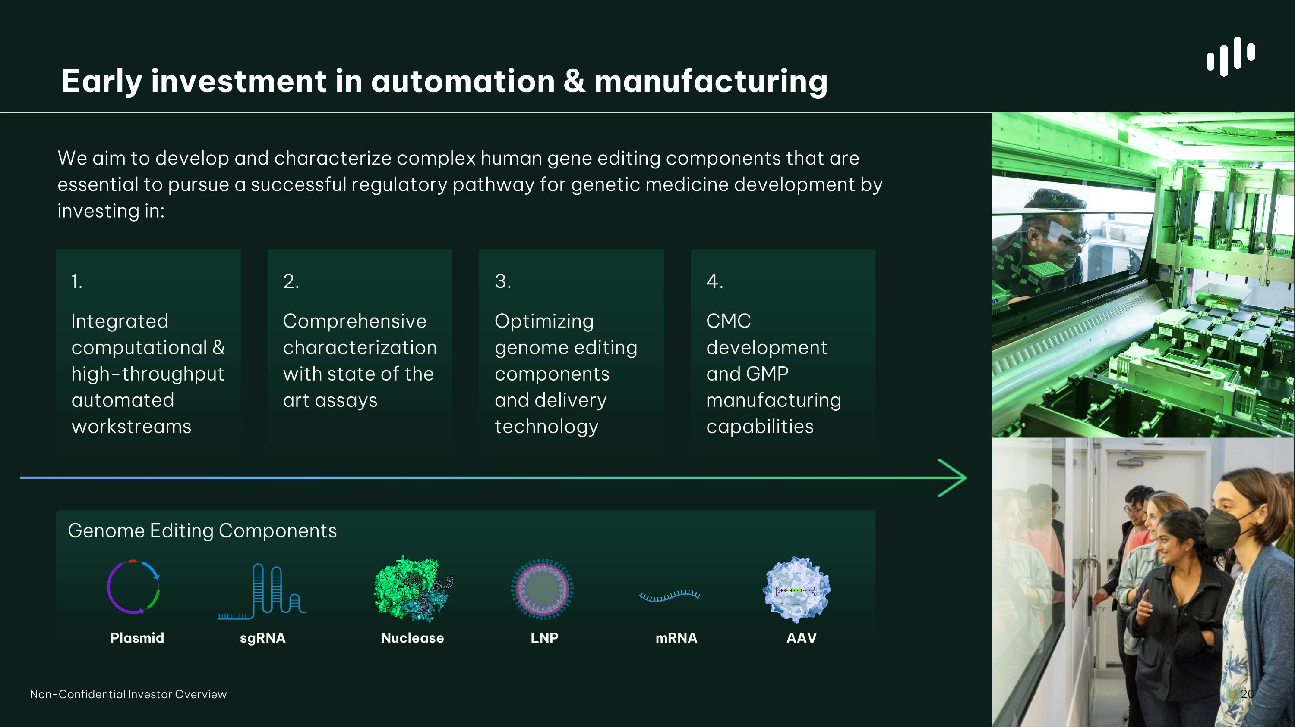
Early investment in automation & manufacturing We aim to develop and characterize complex human gene editing components that are essential to pursue a successful regulatory pathway for genetic medicine development by investing in: 1. Integrated computational & high-throughput automated workstreams 2. Comprehensive characterization with state of the art assays 4. CMC development and GMP manufacturing capabilities Plasmid Nuclease mRNA sgRNA LNP AAV Genome Editing Components 3. Optimizing genome editing components and delivery technology Non-Confidential Investor Overview 20


Brian Thomas, PhD ?CEO & Founder Prior to co-founding the company, Dr. Thomas spent more than 20 years in academic research helping to pioneer the field of metagenomics. Dr. Thomas has been cited over 16,000 times and listed as an inventor in 28 patent families. Luis Borges, PhD?CSO Spent over 27 years in the biotechnology industry in leadership roles overseeing the research and development of multiple therapeutic candidates including cell therapies. Jian Irish, PhD, MBA?President & COO Held biopharma executive leadership roles for nearly 20 years in drug development and global operations, and has helped launch several breakthrough medicines. Pamela Wapnick, MBA?CFO Spent over 20 years in diversified financial leadership positions, spanning strategic and operational finance roles at public and private companies including life sciences and biotechnology companies. Sarah Noonberg, MD, PhD?CMO Spent more than 20 years in translational and clinical development leadership roles with a track record of advancing therapeutic programs from discovery to commercialization. 21 Simon Harnest, MSc ?CIO & SVP of Investor Relations Held leadership roles in corporate finance and strategy in the life sciences sector, having raised over $1bn in public and private capital, including leading IPO and spin-out. Alan Brooks, PhD?SVP of Preclinical Worked on genetic medicines providing scientific leadership in translational research for more than 25 years. Dr. Brooks’ research has led to 20 publications and numerous patent filings. Chris Brown, PhD?VP of Discovery Former scientist at the Jill Banfield lab and an expert in using metagenomics to discover novel microbial systems for use in genome editing. Dr. Brown’s research has resulted in over 35 publications and over 20 patent family filings. Leadership team Non-Confidential Investor Overview

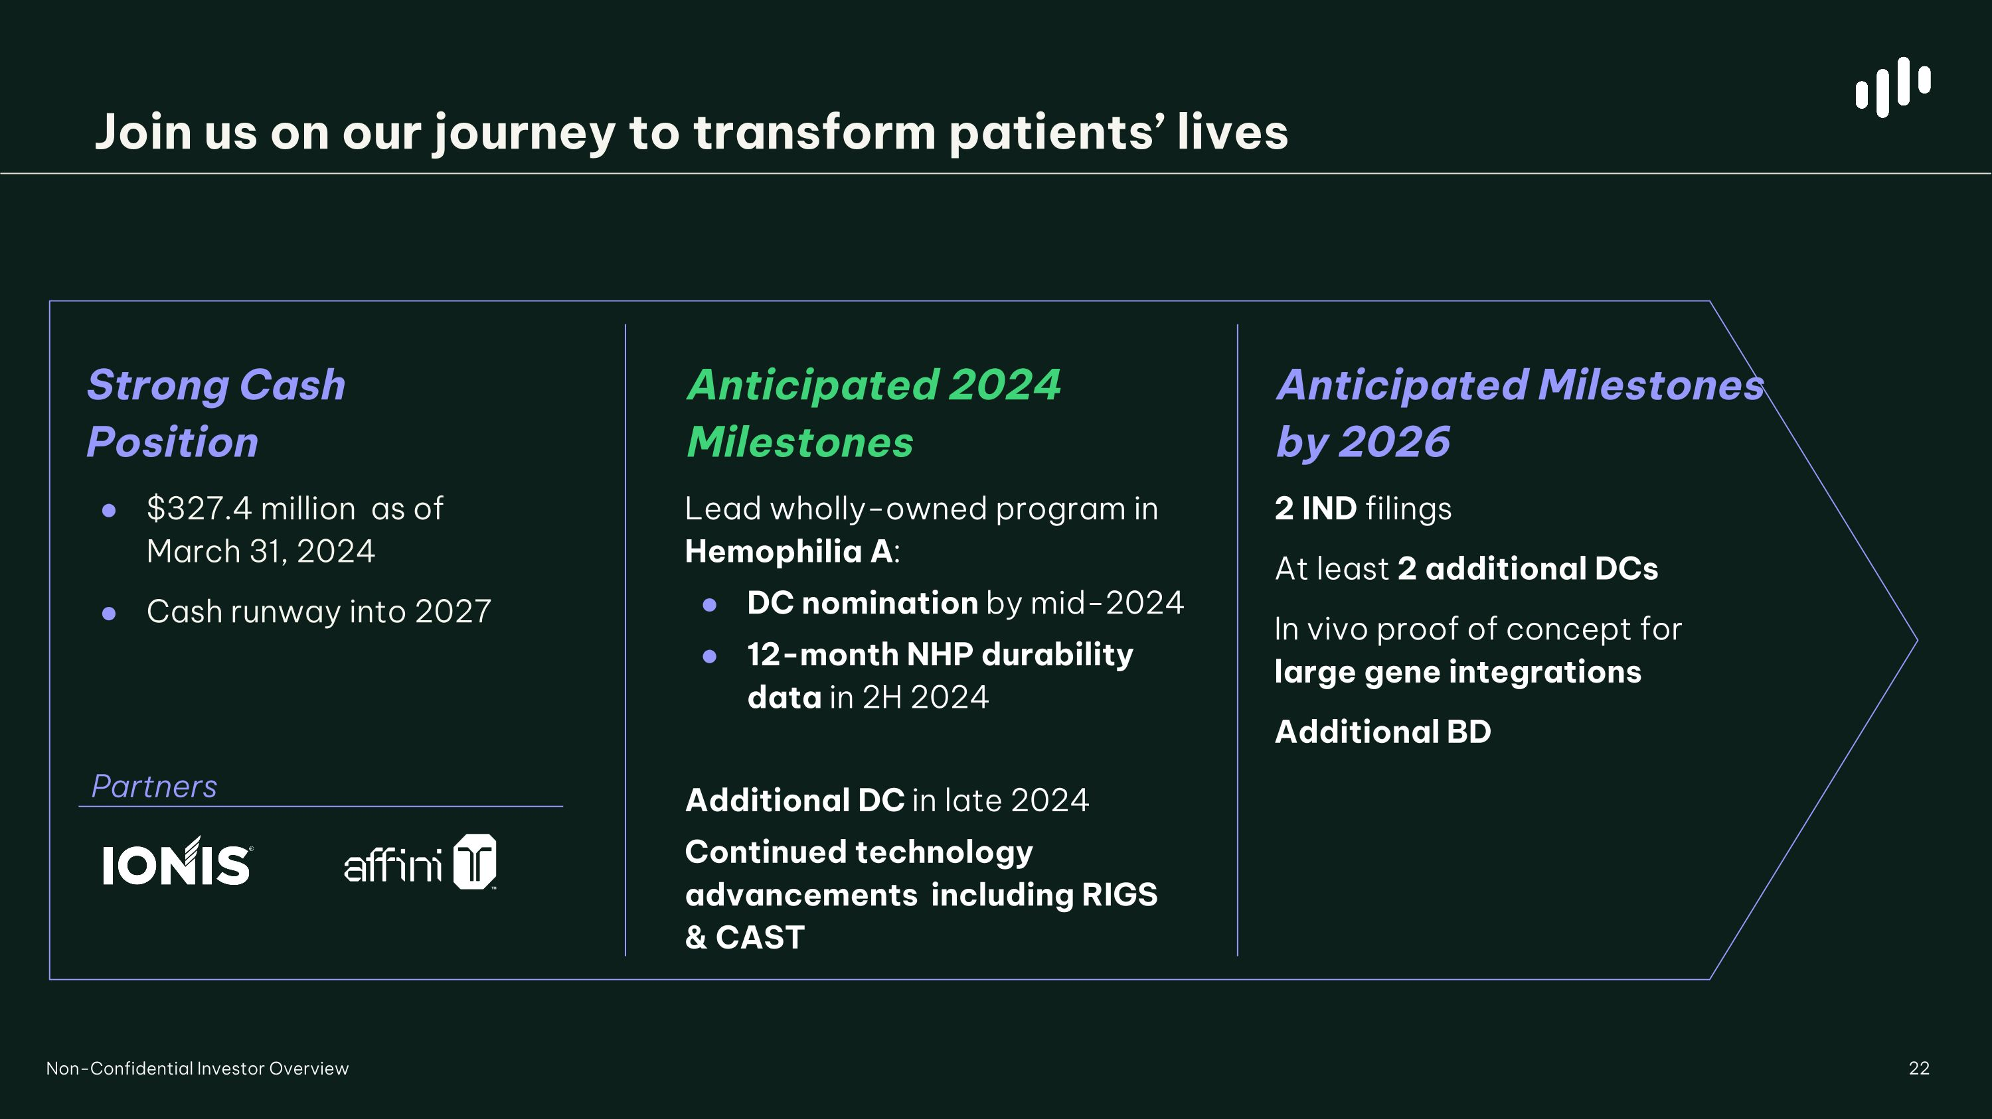
22 Strong Cash ?Position $327.4 million as of ?March 31, 2024 Cash runway into 2027 Partners Non-Confidential Investor Overview Join us on our journey to transform patients’ lives Anticipated Milestones by 2026 2 IND filings At least 2 additional DCs In vivo proof of concept for large gene integrations Additional BD Anticipated 2024 Milestones Lead wholly-owned program in Hemophilia A: DC nomination by mid-2024 12-month NHP durability data in 2H 2024 Additional DC in late 2024 Continued technology advancements including RIGS & CAST


Thank you 23 Non-Confidential Investor Overview Investor Contact: Simon Harnest, MSc CIO & SVP of Investor Relations simon@metagenomi.co

